

**Student Portal**

**Usability test plan**

**Facilitator: Sergiu Tripon**

**Participant: Pratiksha Vekaria**

**Version:** 1.0

**Writer:** Sergiu Tripon

**Date:** 04/04/2015

Contents

Introduction 4

Test cases 5

Test results 35

Github 45

Conclusion 50

# Introduction

This document details the events occurred during the usability testing phase of the Student Portal application. It is made out of 5 main chapters. The first chapter showcases the test cases that were created and used by the participant to test the application’s usability. The results are shown in the second chapter.

# Test cases

**Recording URL:** <https://student-portal.co.uk/usability-testing/?video=full-video>

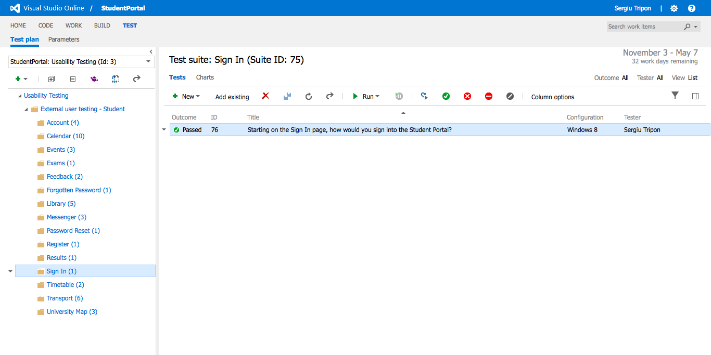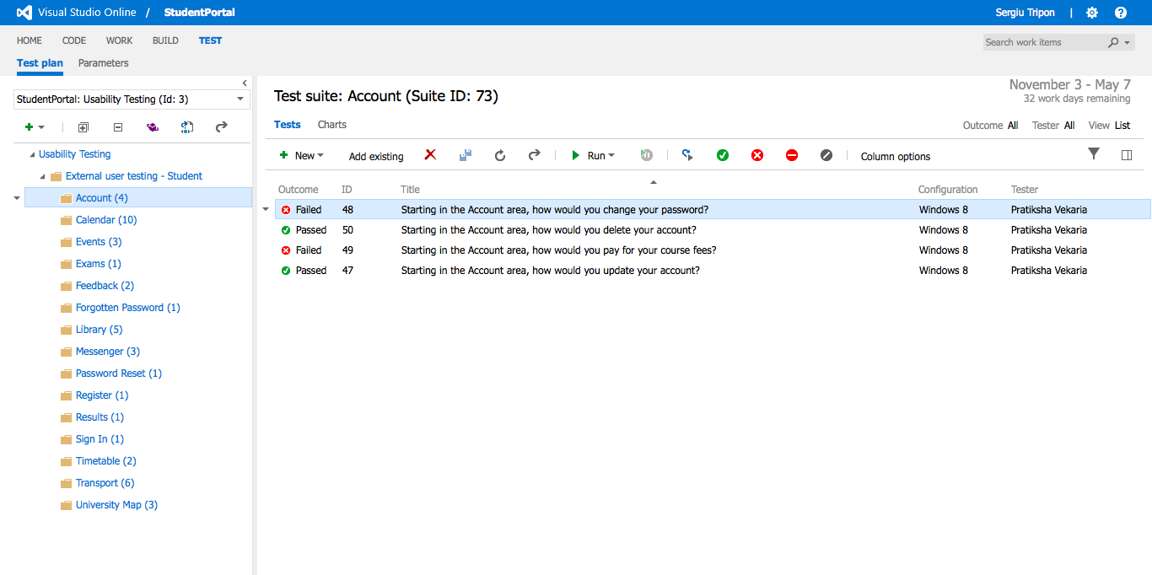

**Test cases - Overview**

**Recording URL:** <https://student-portal.co.uk/usability-testing/?video=sign-in>



**Sign In** - overview of the test case(s)

**Recording URL:** <https://student-portal.co.uk/usability-testing/?video=sign-in>

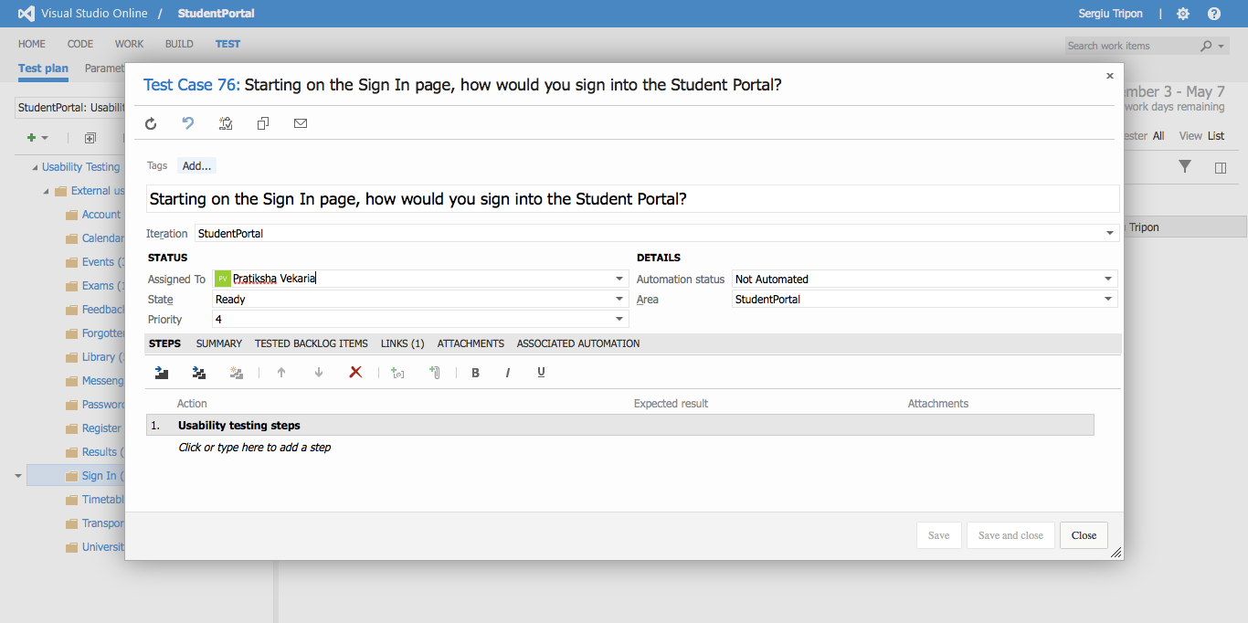

**Sign In** - detailed view of test case

**Recording URL:** <https://student-portal.co.uk/usability-testing/?video=register>

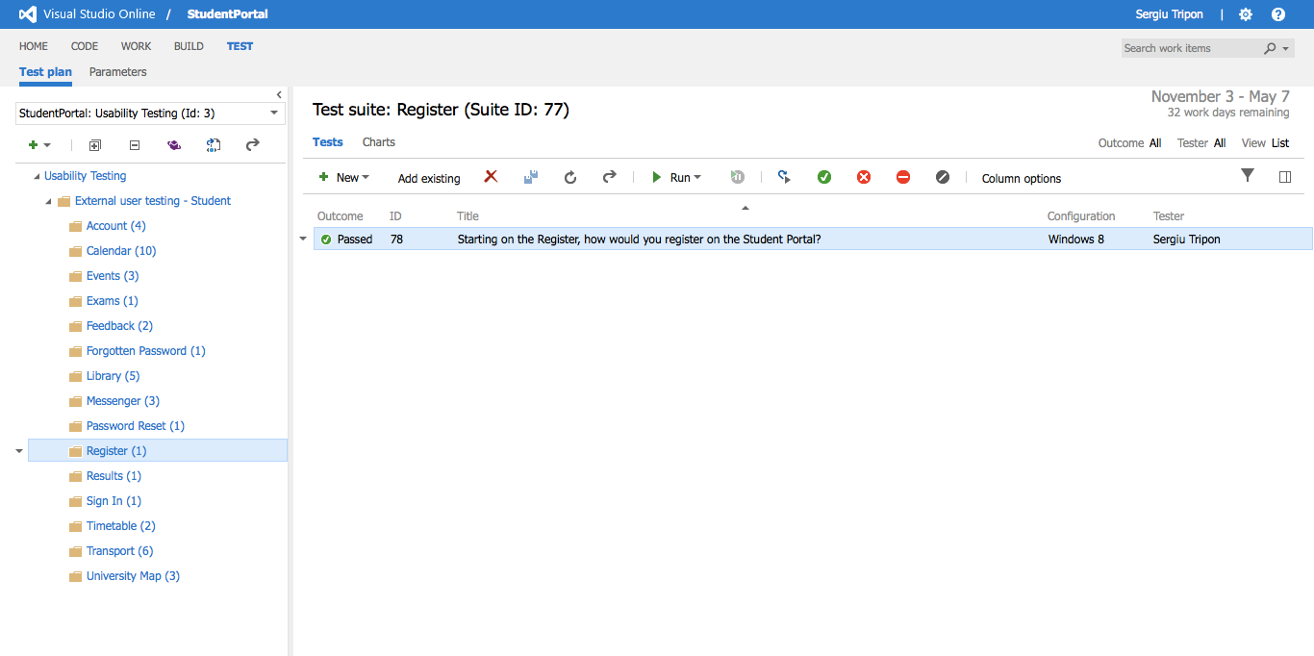

**Register** - overview of the test case(s)

**Recording URL:** <https://student-portal.co.uk/usability-testing/?video=register>

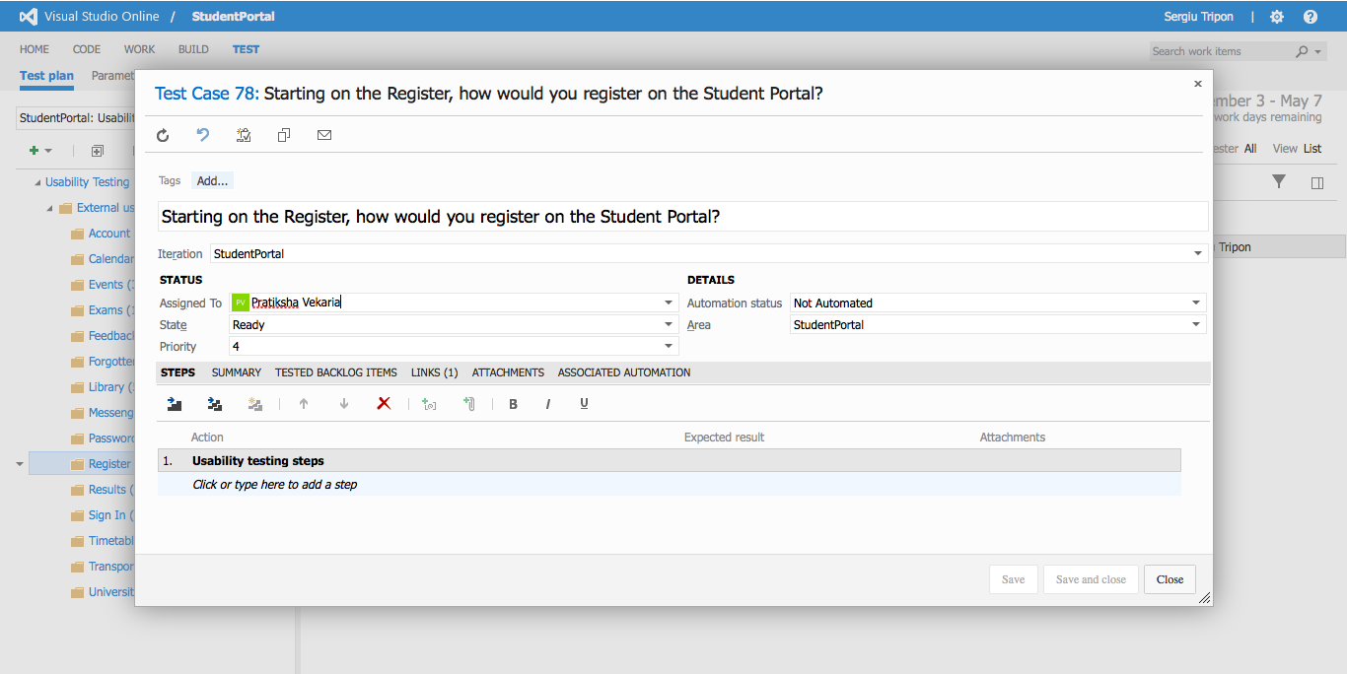

**Register** - detailed view of a test case

**Recording URL:** <https://student-portal.co.uk/usability-testing/?video=forgotten-password>

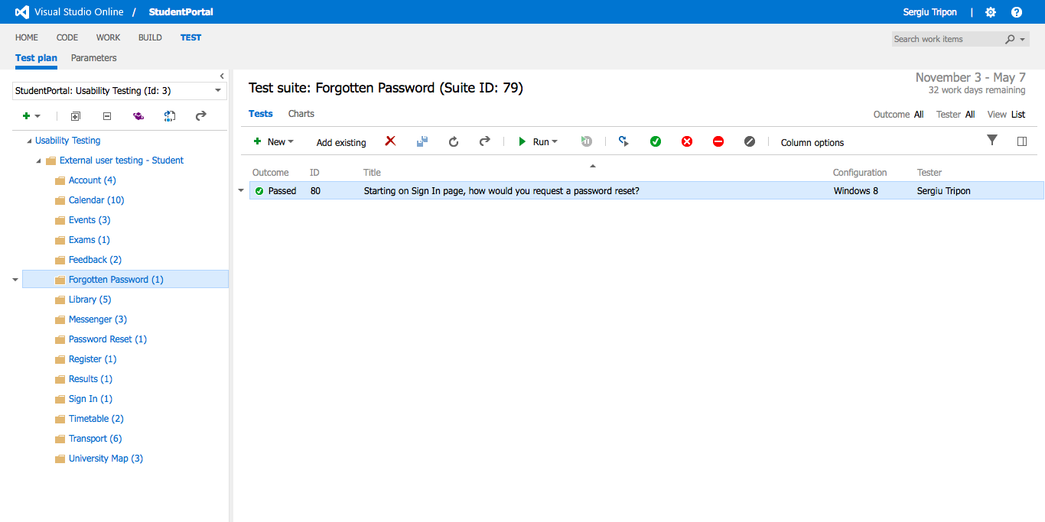

**Forgotten password** - overview of the test case(s)

**Recording URL:** <https://student-portal.co.uk/usability-testing/?video=forgotten-password>

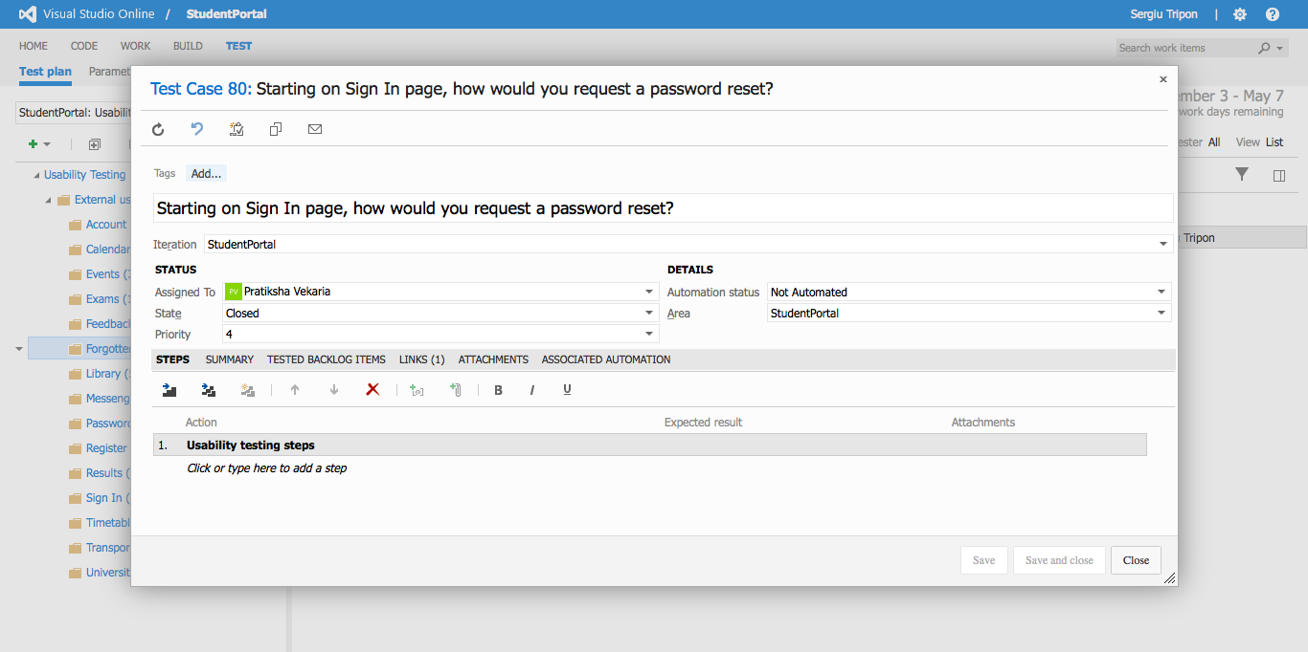

**Forgotten password** - detailed view of a test case

**Recording URL:** <https://student-portal.co.uk/usability-testing/?video=password-reset>

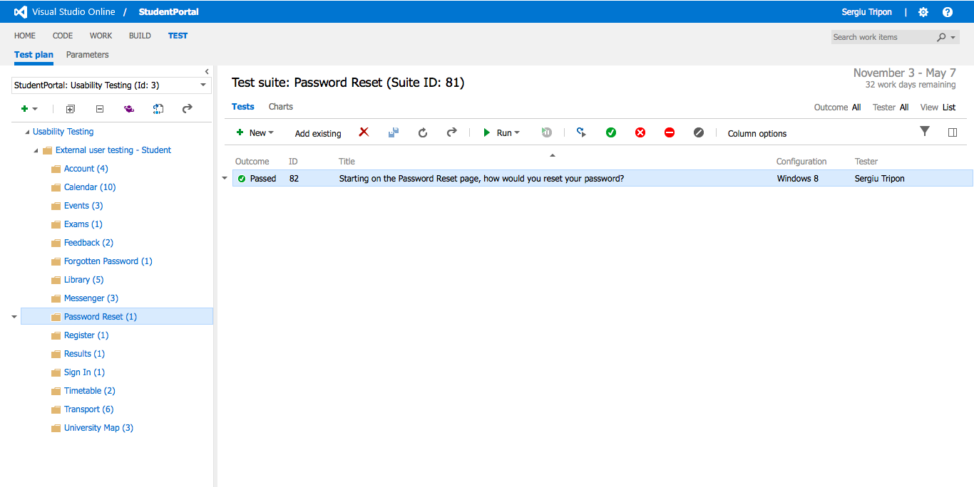

**Password reset** - overview of the test case(s)

**Recording URL:** <https://student-portal.co.uk/usability-testing/?video=password-reset>

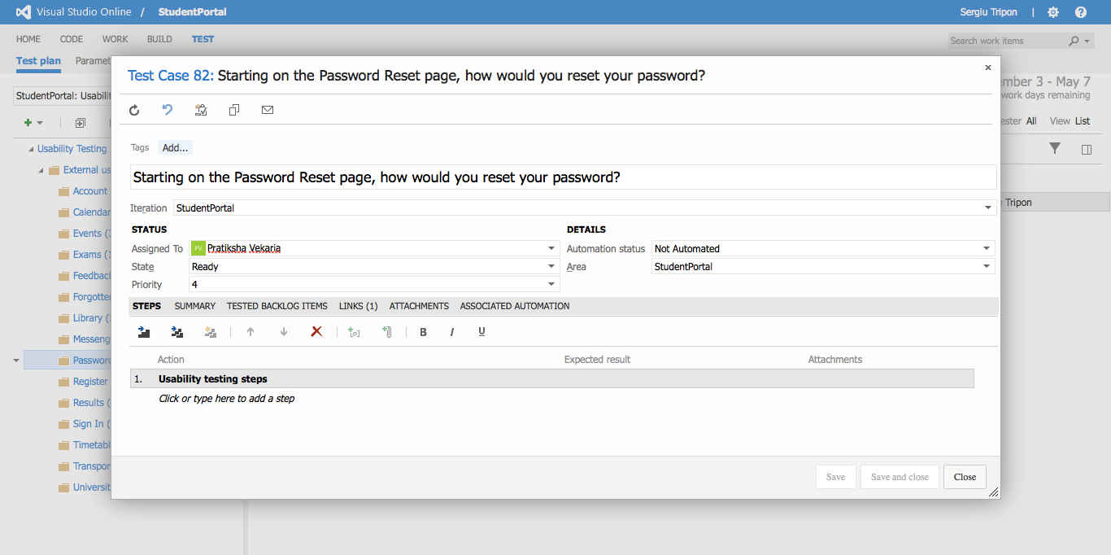

**Password reset** - detailed view of a test case

**Recording URL:** <https://student-portal.co.uk/usability-testing/?video=timetable>

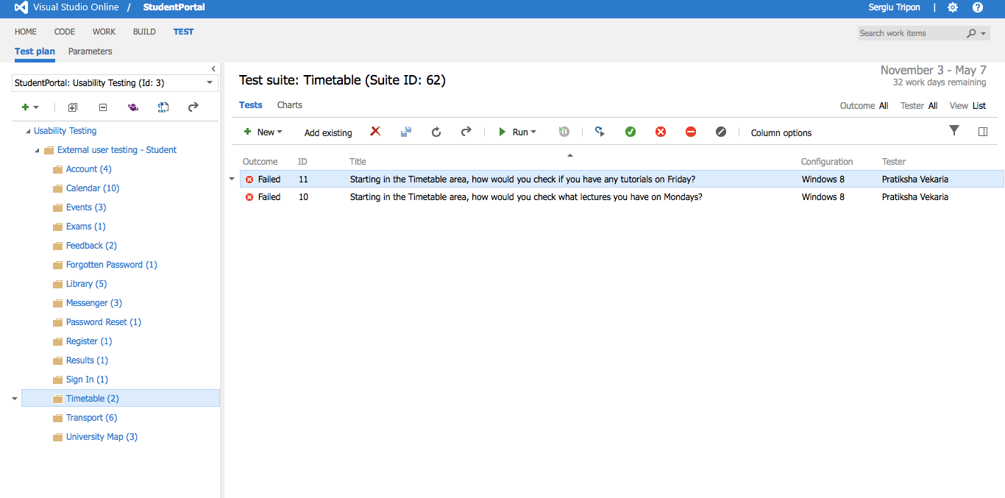

**Timetable** - overview of the test case(s)

**Recording URL:** <https://student-portal.co.uk/usability-testing/?video=timetable>

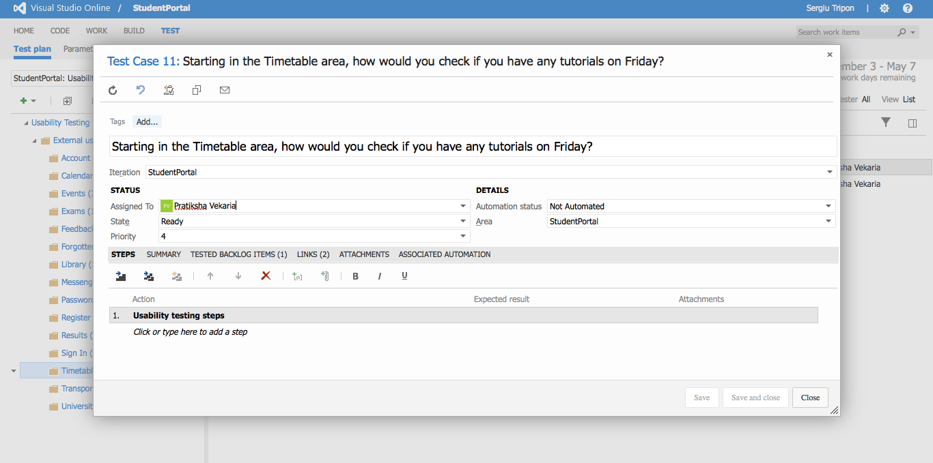

**Timetable** - detailed view of a test case

**Recording URL:** <https://student-portal.co.uk/usability-testing/?video=timetable>

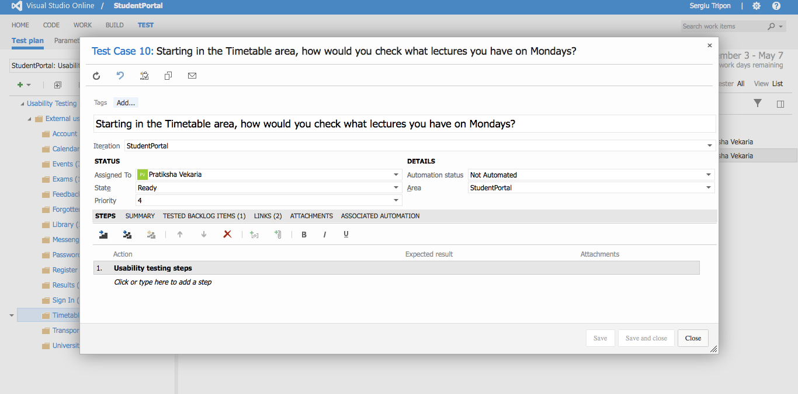

**Timetable** - detailed view of a test case

**Recording URL:** <https://student-portal.co.uk/usability-testing/?video=exams>

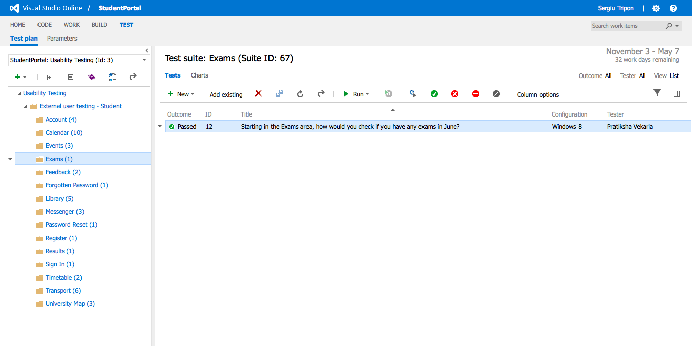

**Exams** - overview of the test case(s)

**Recording URL:** <https://student-portal.co.uk/usability-testing/?video=exams>

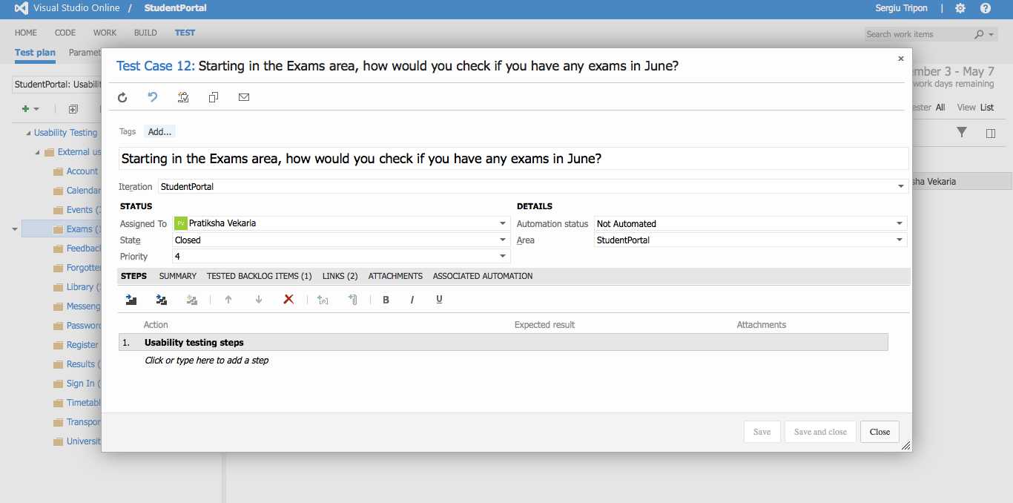

**Exams** - detailed view of a test case

**Recording URL:** <https://student-portal.co.uk/usability-testing/?video=results>

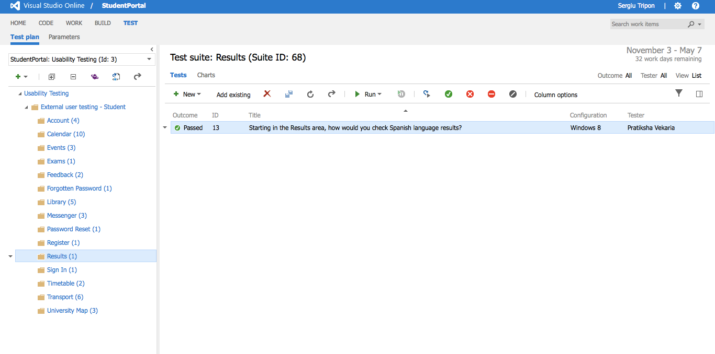

**Results** - overview of the test case(s)

**Recording URL:** <https://student-portal.co.uk/usability-testing/?video=results>

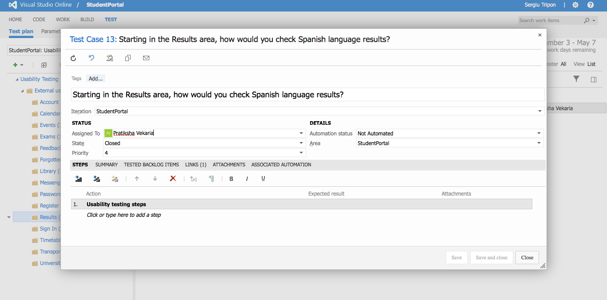

**Results** - detailed view of a test case

**Recording URL:** <https://student-portal.co.uk/usability-testing/?video=transport>

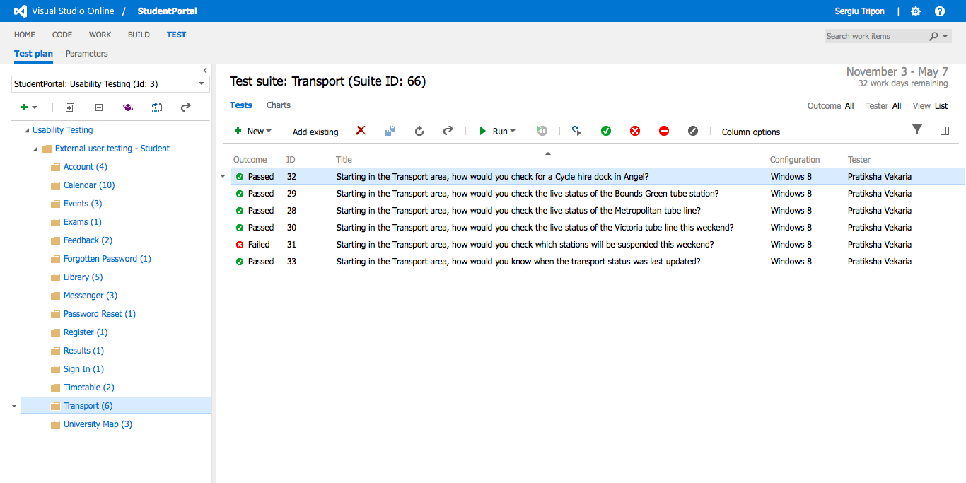

**Transport** - overview of the test case(s)

**Recording URL:** <https://student-portal.co.uk/usability-testing/?video=transport>

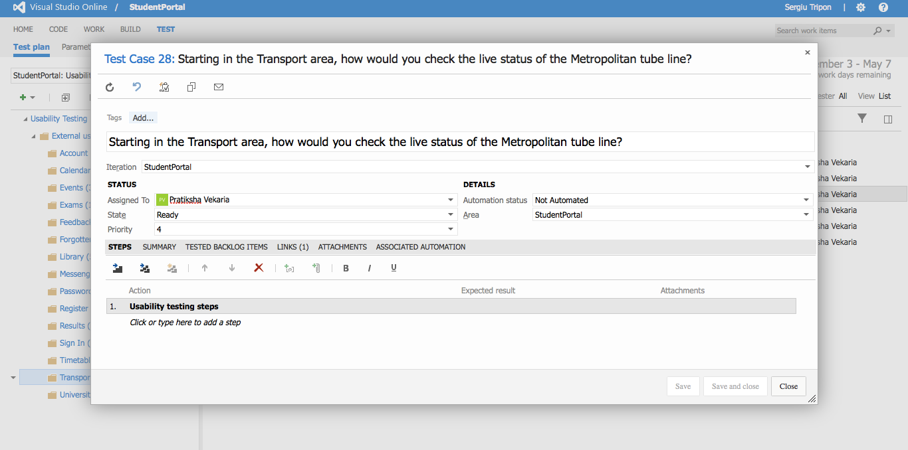

**Transport** - detailed view of a test case

**Recording URL:** <https://student-portal.co.uk/usability-testing/?video=transport>

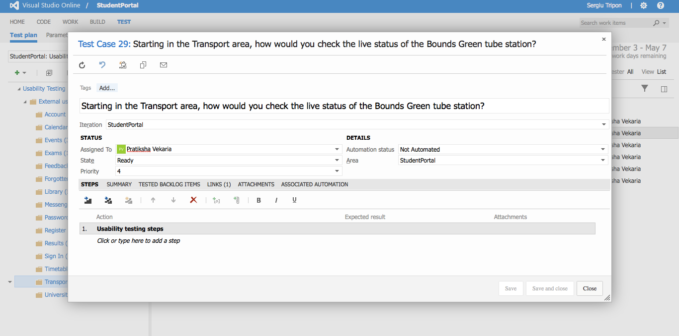

**Transport** - detailed view of a test case

**Recording URL:** <https://student-portal.co.uk/usability-testing/?video=timetable>

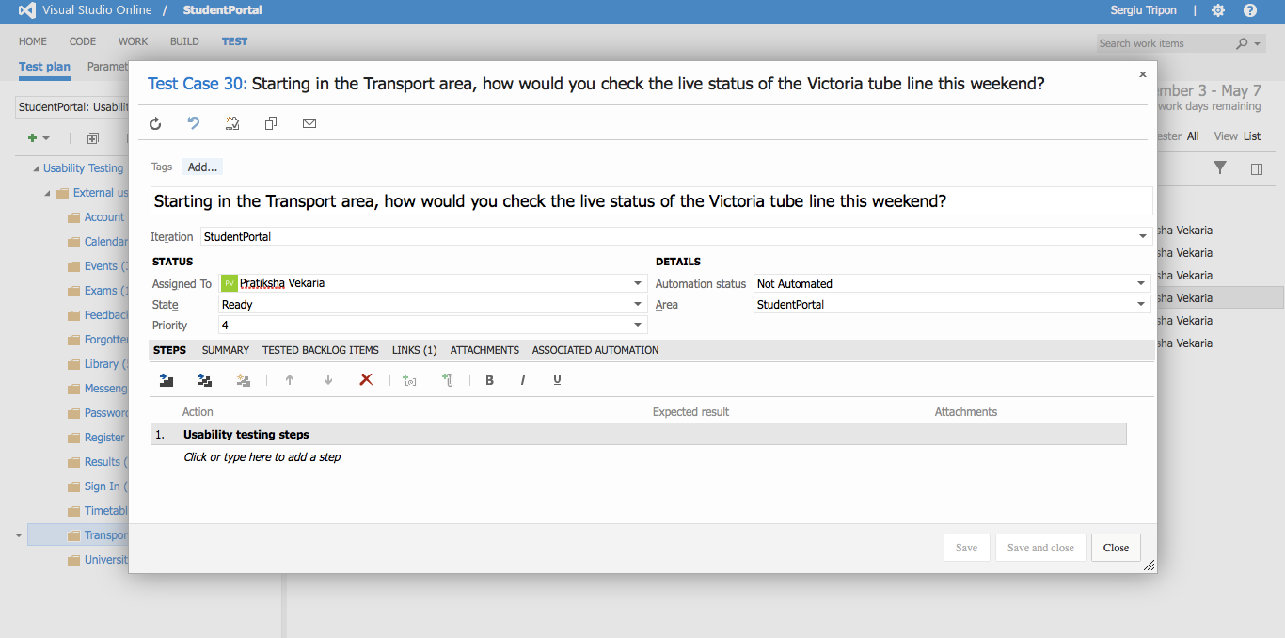

**Transport** - detailed view of a test case

**Recording URL:** <https://student-portal.co.uk/usability-testing/?video=transport>

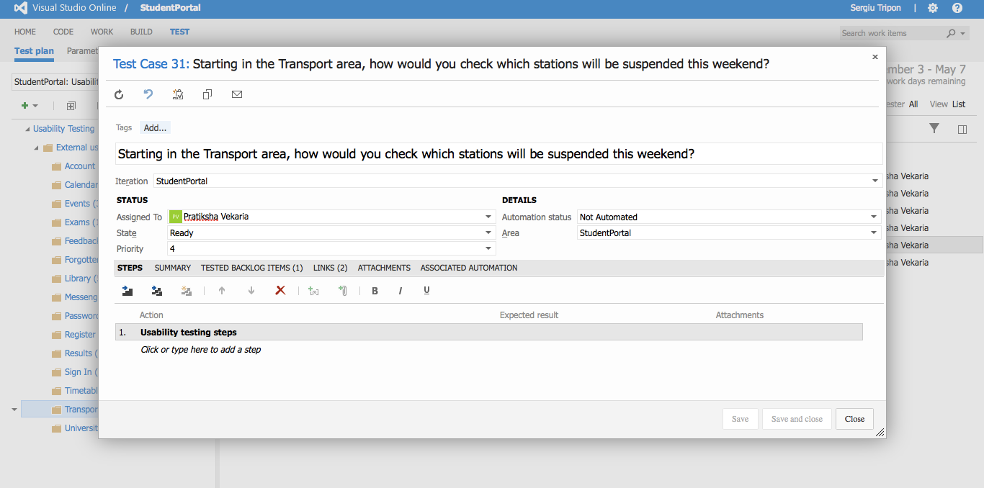

**Transport** - detailed view of a test case

**Recording URL:** <https://student-portal.co.uk/usability-testing/?video=transport>

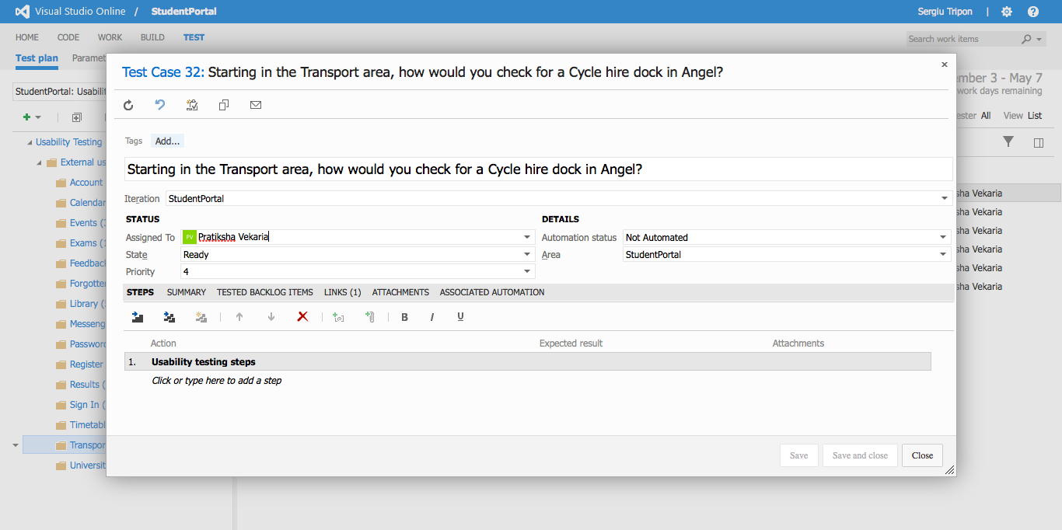

**Transport** - detailed view of a test case

**Recording URL:** <https://student-portal.co.uk/usability-testing/?video=transport>

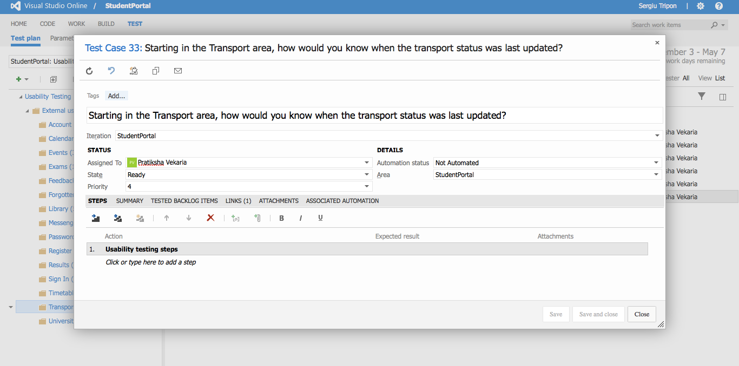

**Transport** - detailed view of a test case

**Recording URL:** <https://student-portal.co.uk/usability-testing/?video=library>

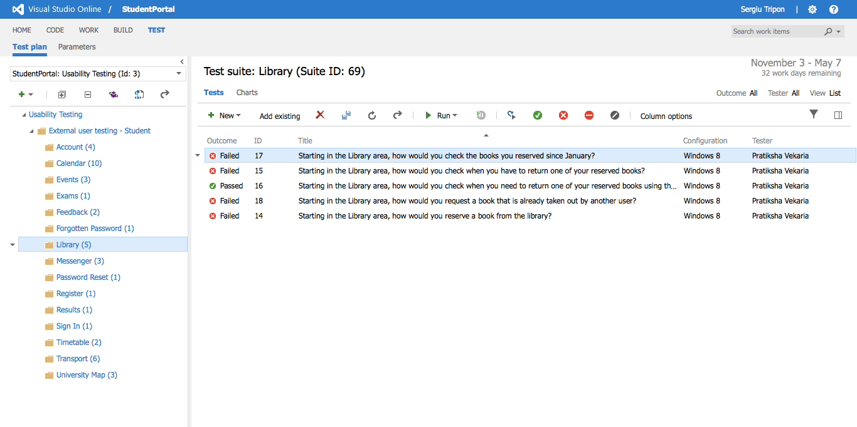

**Library** - overview of the test case(s)

**Recording URL:** <https://student-portal.co.uk/usability-testing/?video=library>

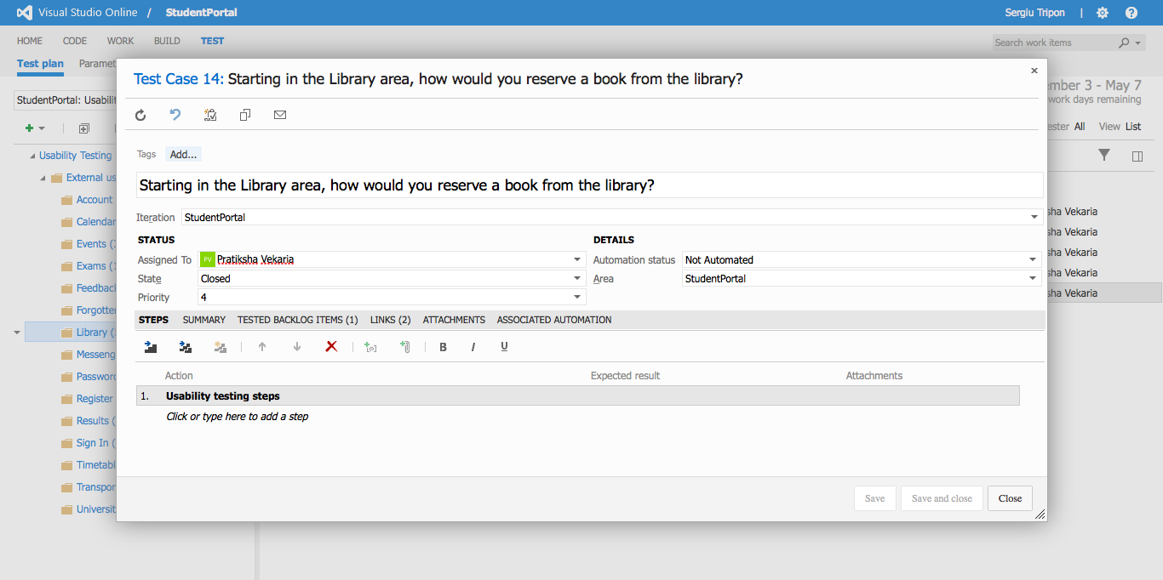

**Library** - detailed view of a test case

**Recording URL:** <https://student-portal.co.uk/usability-testing/?video=library>

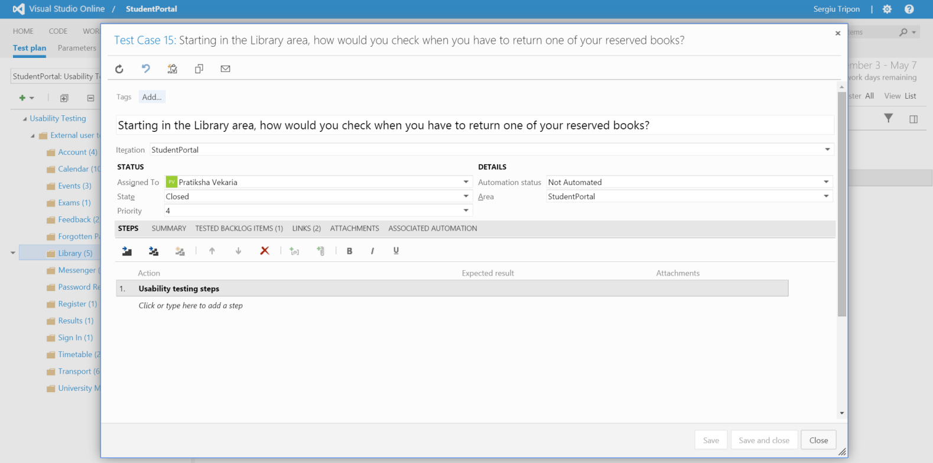

**Library** - detailed view of a test case

**Recording URL:** <https://student-portal.co.uk/usability-testing/?video=library>

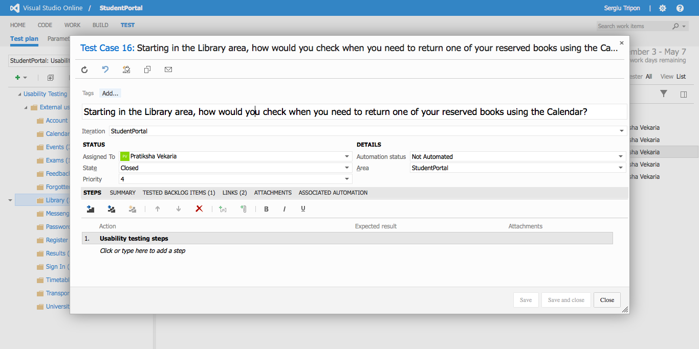

**Library** - detailed view of a test case

**Recording URL:** <https://student-portal.co.uk/usability-testing/?video=library>

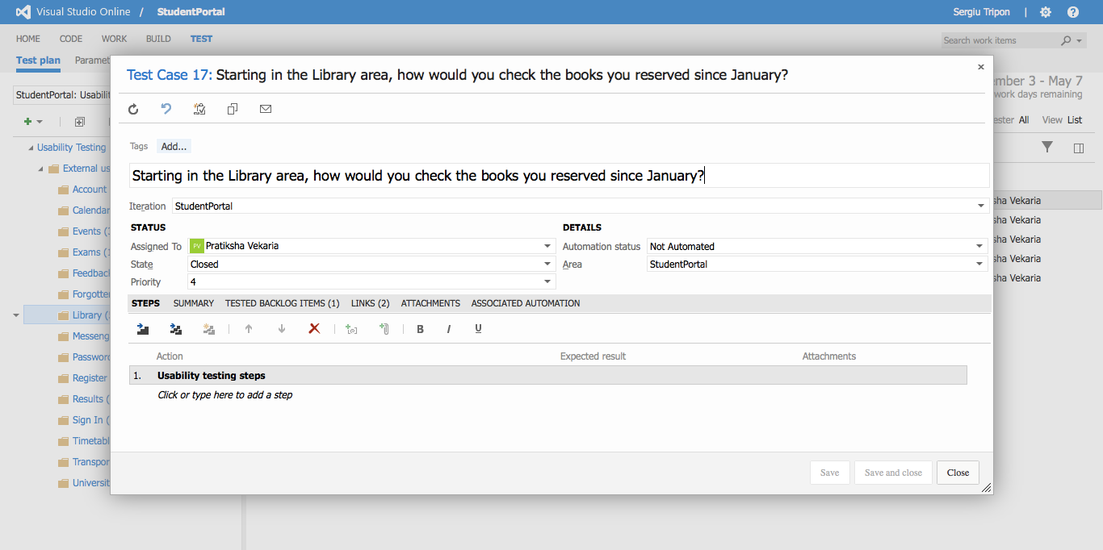

**Library** - detailed view of a test case

**Recording URL:** <https://student-portal.co.uk/usability-testing/?video=library>

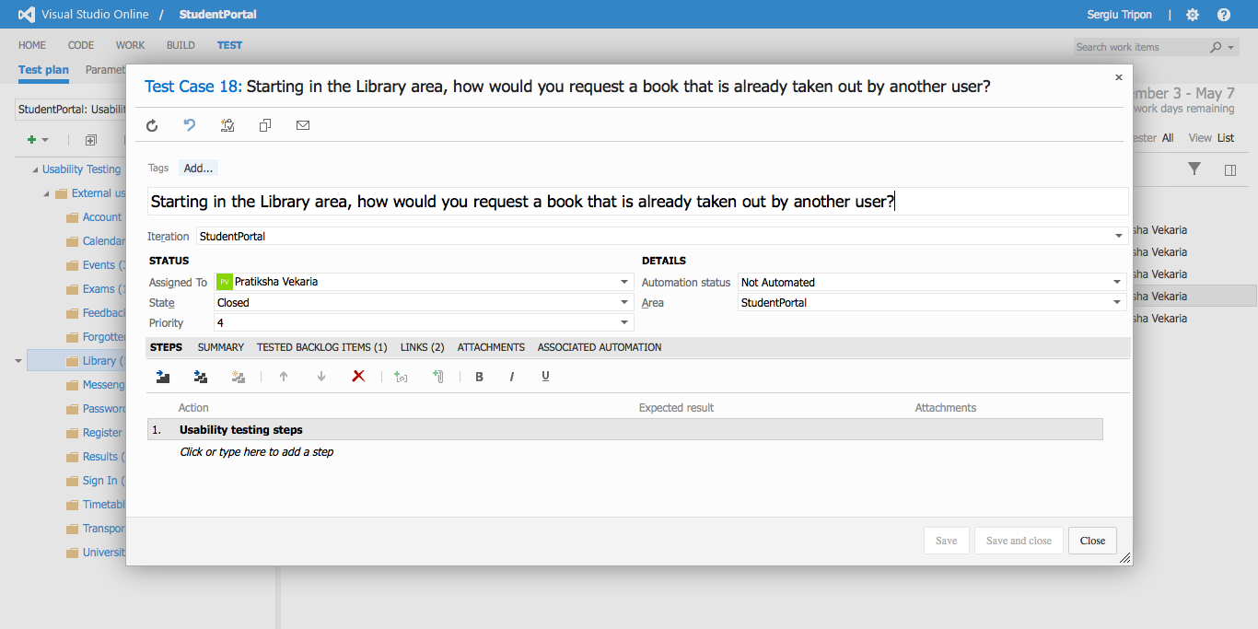

**Library** - detailed view of a test case

**Recording URL:** <https://student-portal.co.uk/usability-testing/?video=calendar>

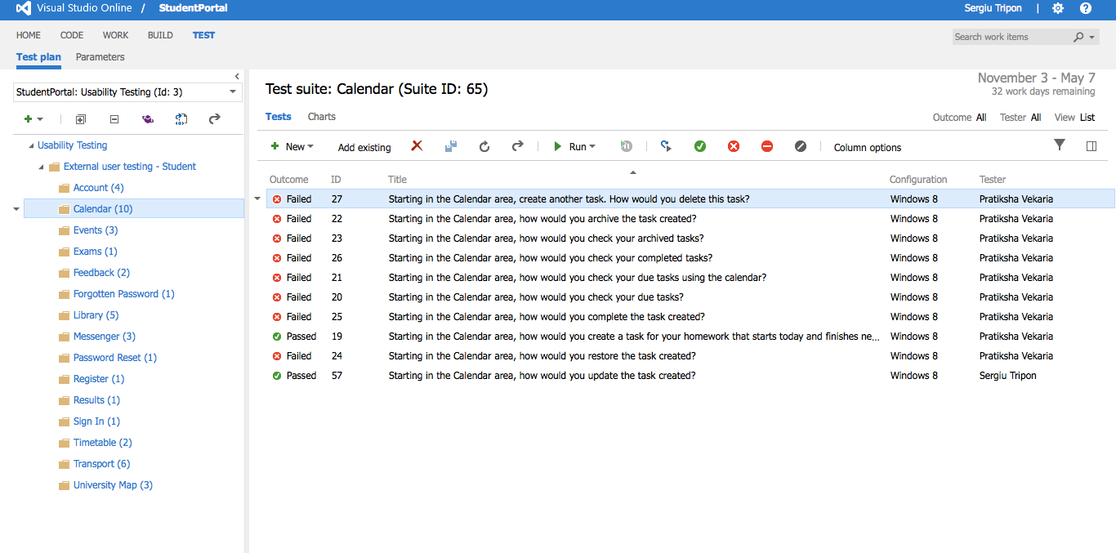

**Calendar** - overview of the test case(s)

**Recording URL:** <https://student-portal.co.uk/usability-testing/?video=calendar>

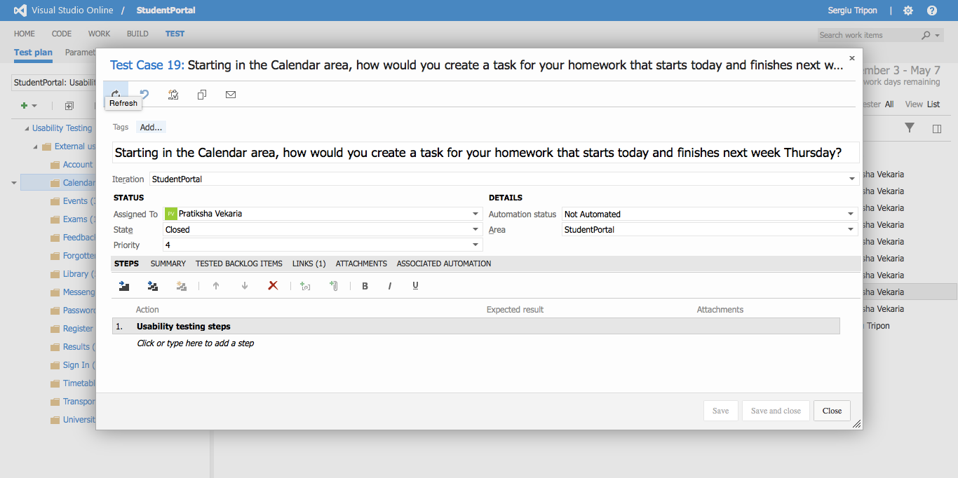

**Calendar** - detailed view of a test case

**Recording URL:** <https://student-portal.co.uk/usability-testing/?video=calendar>

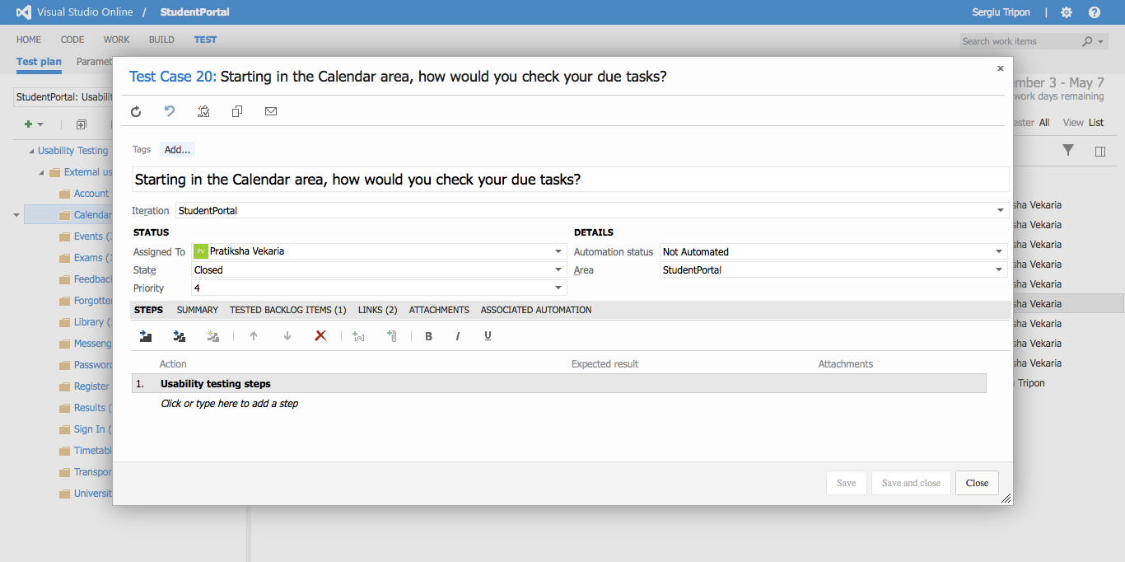

**Calendar** - detailed view of a test case

**Recording URL:** <https://student-portal.co.uk/usability-testing/?video=calendar>

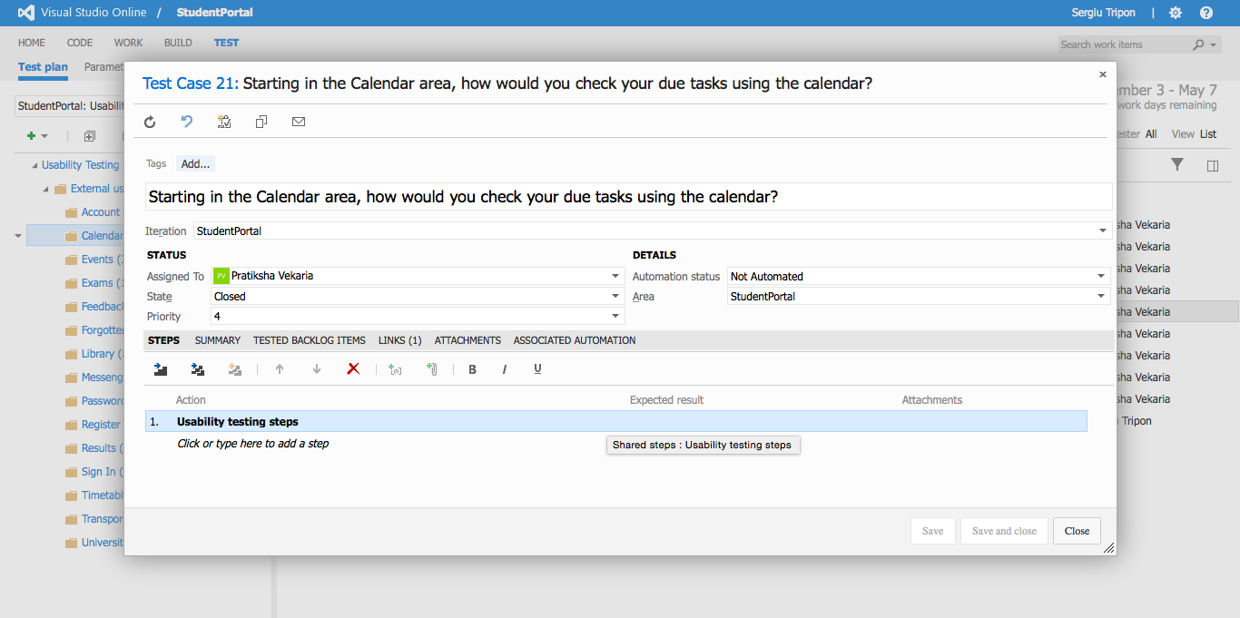

**Calendar** - detailed view of a test case

**Recording URL:** <https://student-portal.co.uk/usability-testing/?video=calendar>

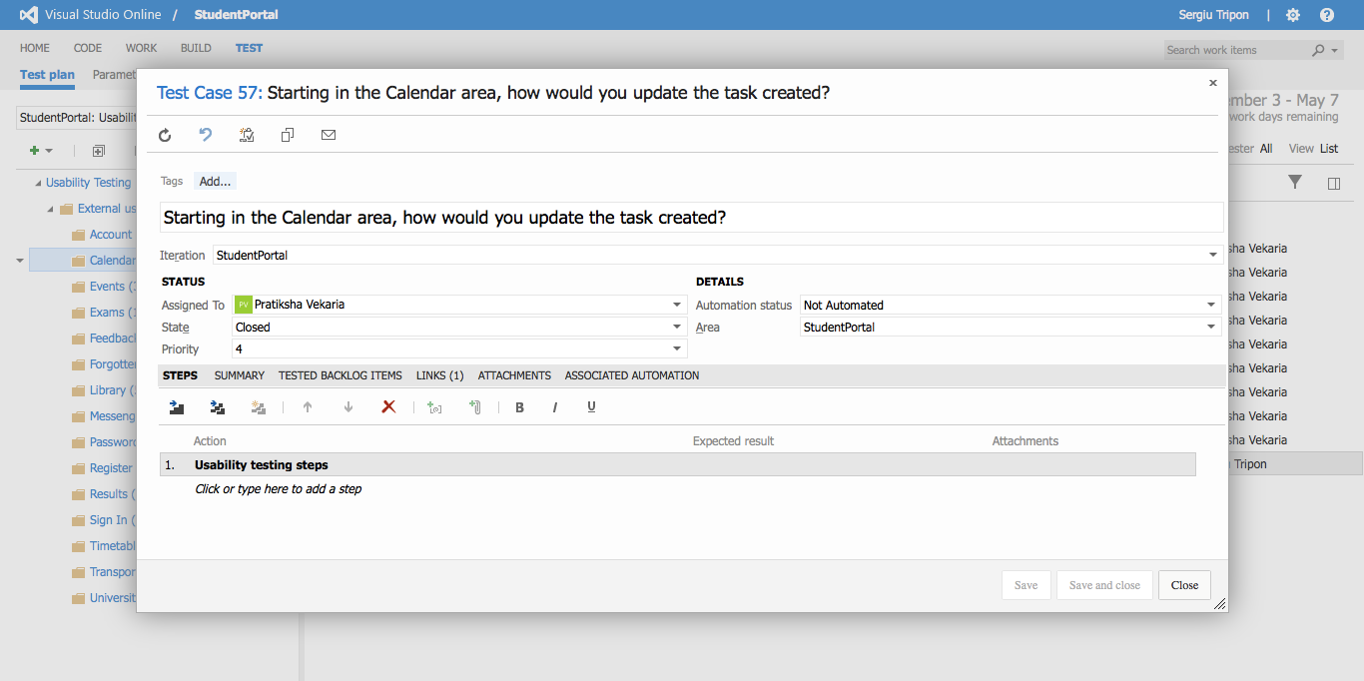

**Calendar** - detailed view of a test case

**Recording URL:** <https://student-portal.co.uk/usability-testing/?video=calendar>

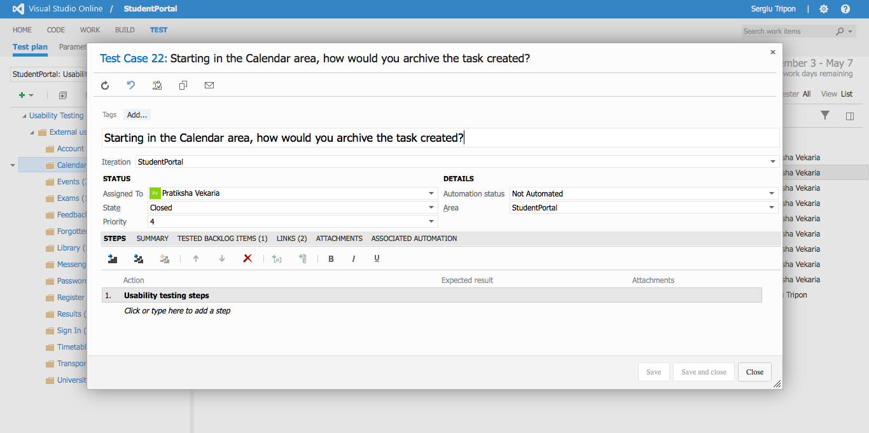

**Calendar** - detailed view of a test case

**Recording URL:** <https://student-portal.co.uk/usability-testing/?video=calendar>

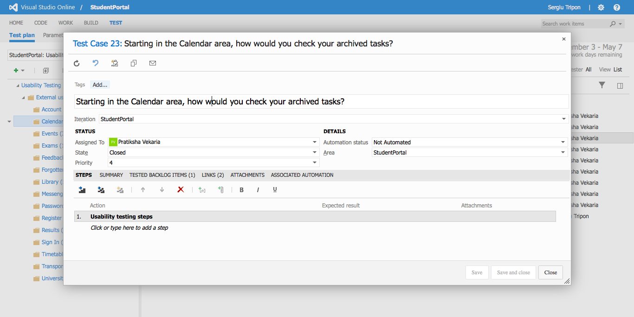

**Calendar** - detailed view of a test case

**Recording URL:** <https://student-portal.co.uk/usability-testing/?video=calendar>

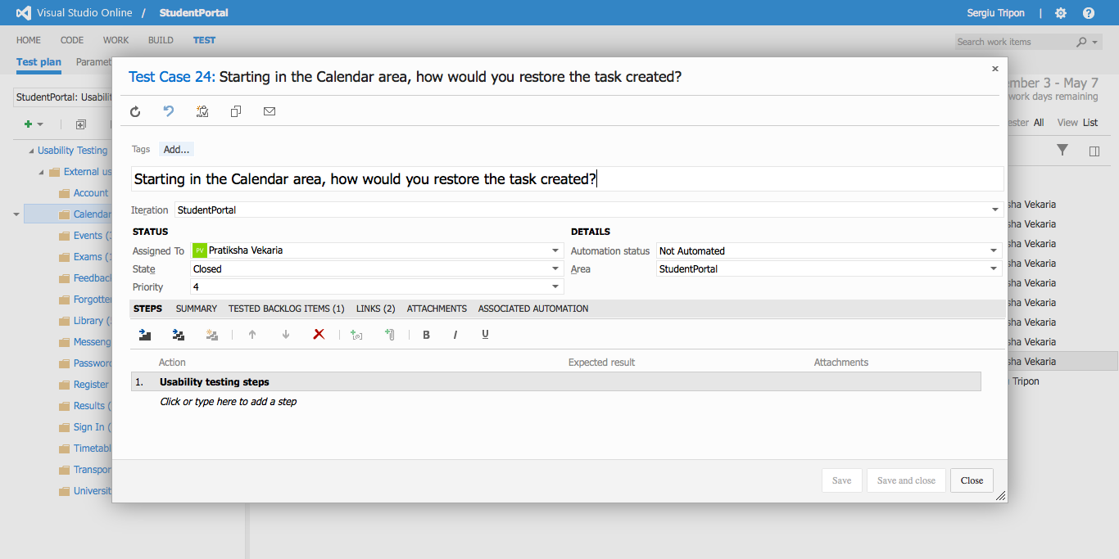

**Calendar** - detailed view of a test case

**Recording URL:** <https://student-portal.co.uk/usability-testing/?video=calendar>

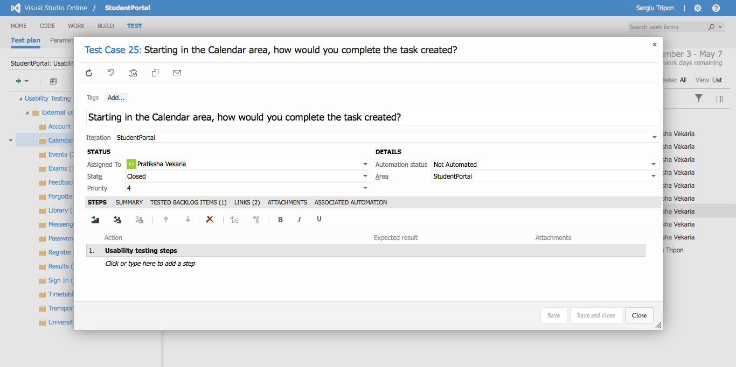

**Calendar** - detailed view of a test case

**Recording URL:** <https://student-portal.co.uk/usability-testing/?video=calendar>

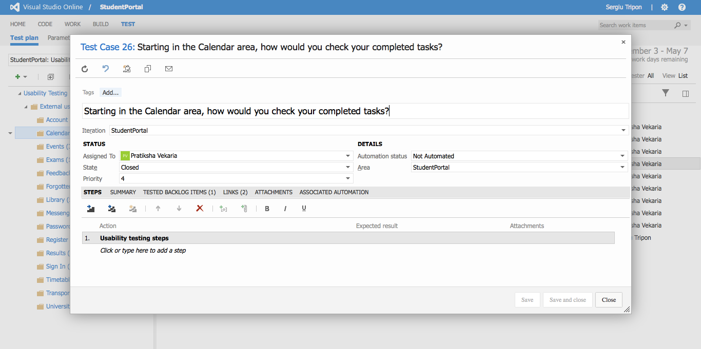

**Calendar** - detailed view of a test case

**Recording URL:** <https://student-portal.co.uk/usability-testing/?video=calendar>

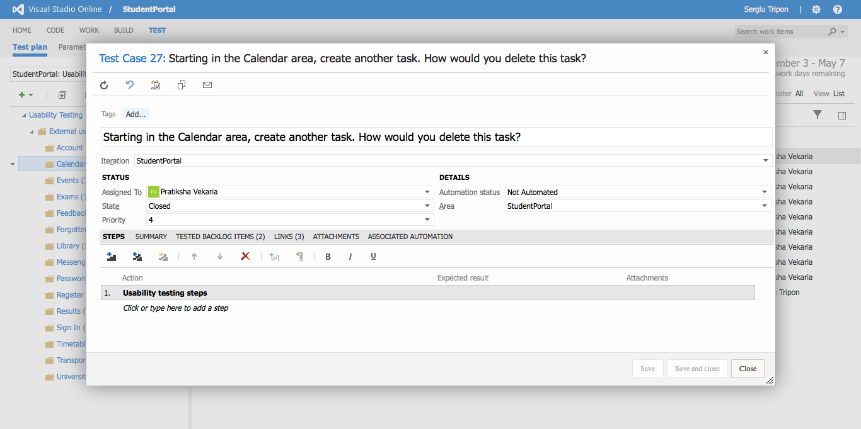

**Calendar** - detailed view of a test case

**Recording URL:** <https://student-portal.co.uk/usability-testing/?video=university-map>

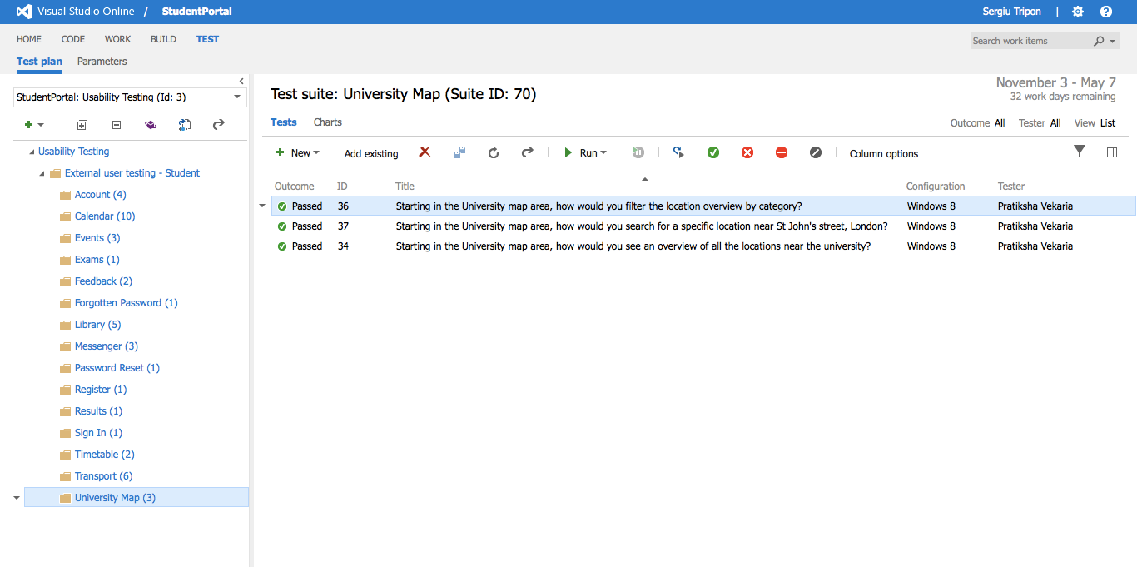

**University Map** - overview of the test case(s)

**Recording URL:** <https://student-portal.co.uk/usability-testing/?video=university-map>

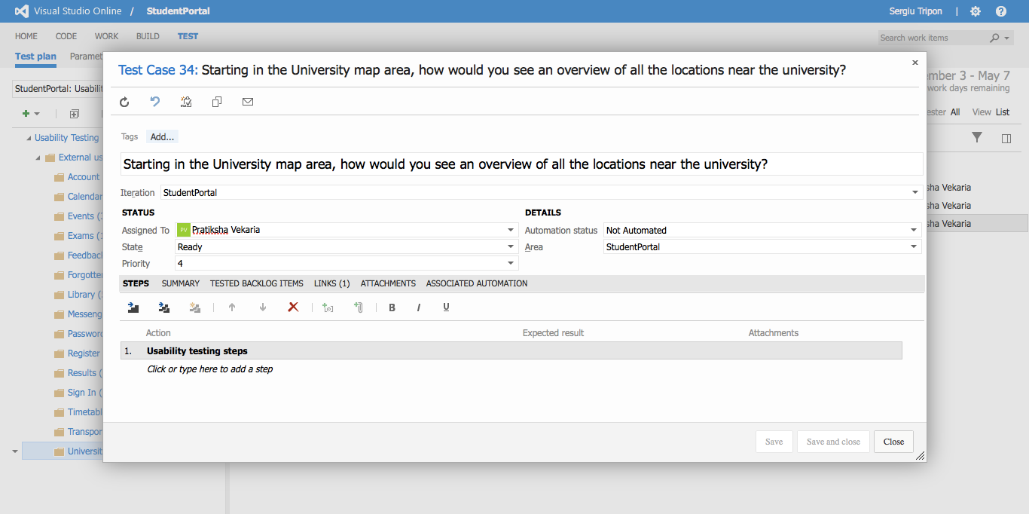

**University Map** - detailed view of a test case

**Recording URL:** <https://student-portal.co.uk/usability-testing/?video=university-map>

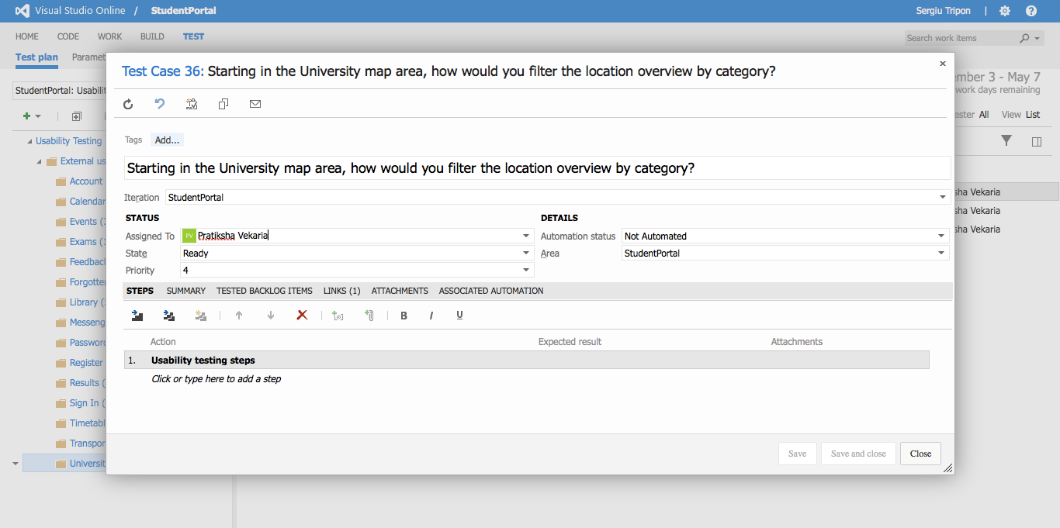

**University Map** - detailed view of a test case

**Recording URL:** <https://student-portal.co.uk/usability-testing/?video=university-map>

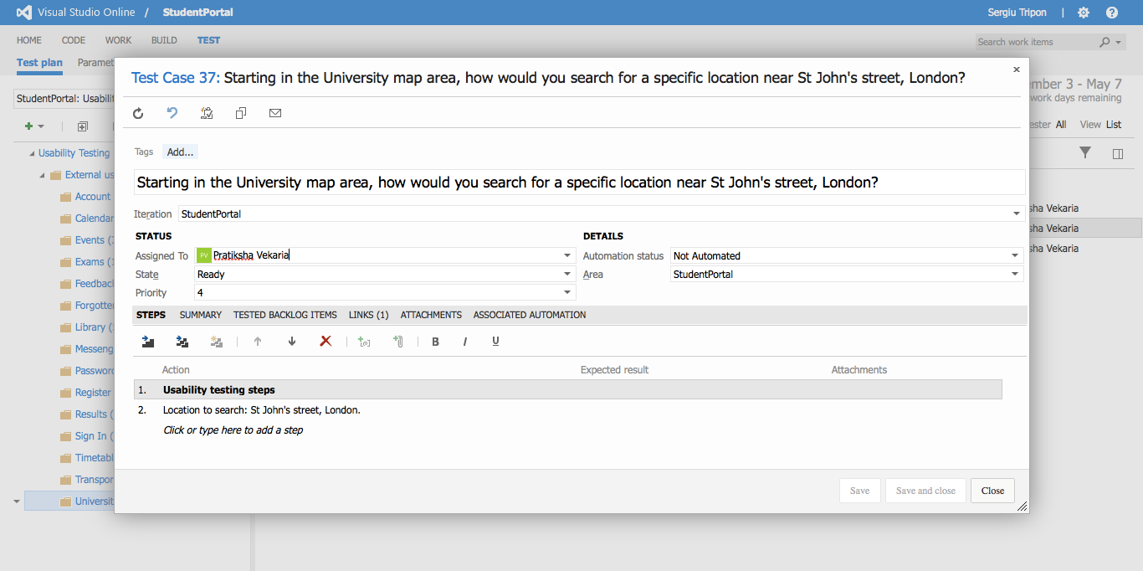

**University Map** - detailed view of a test case

**Recording URL:** <https://student-portal.co.uk/usability-testing/?video=events>

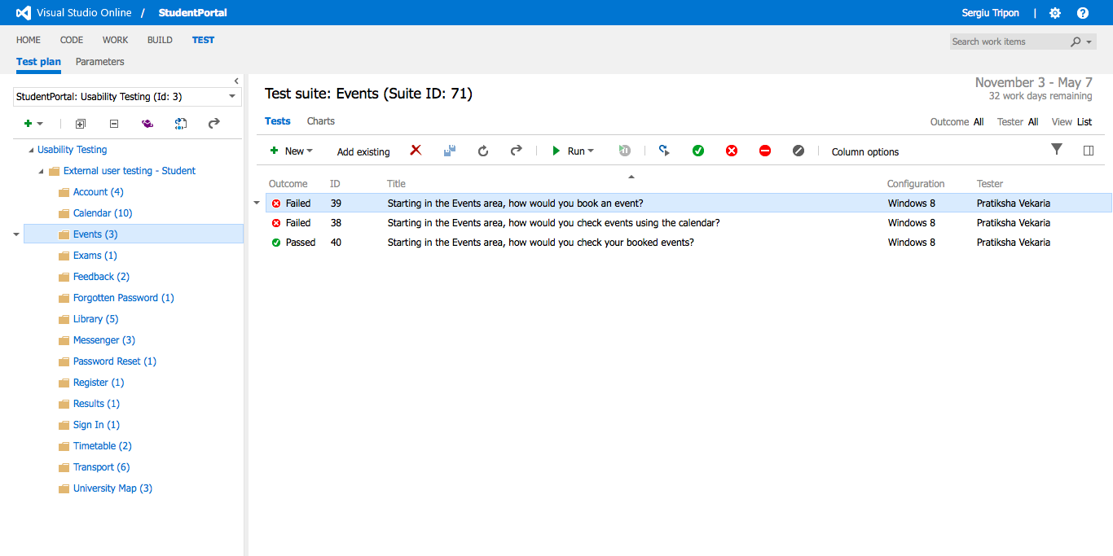

**Events** - overview of the test case(s)

**Recording URL:** <https://student-portal.co.uk/usability-testing/?video=events>

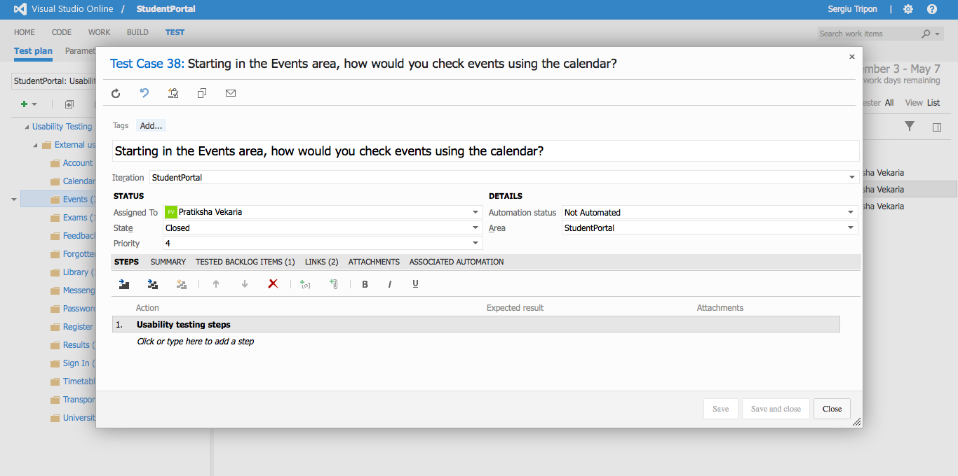

**Events** - detailed view of a test case

**Recording URL:** <https://student-portal.co.uk/usability-testing/?video=events>

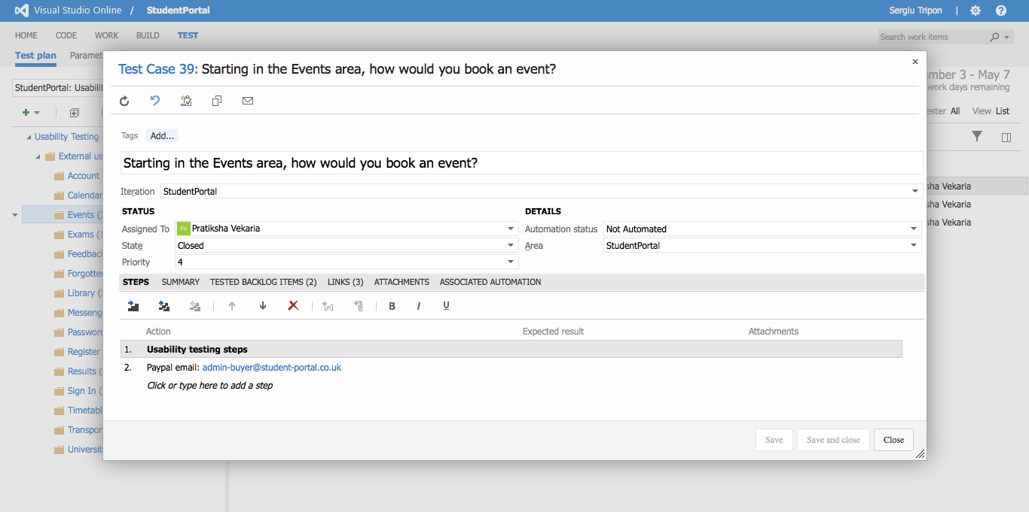

**Events** - detailed view of a test case

**Recording URL:** <https://student-portal.co.uk/usability-testing/?video=events>

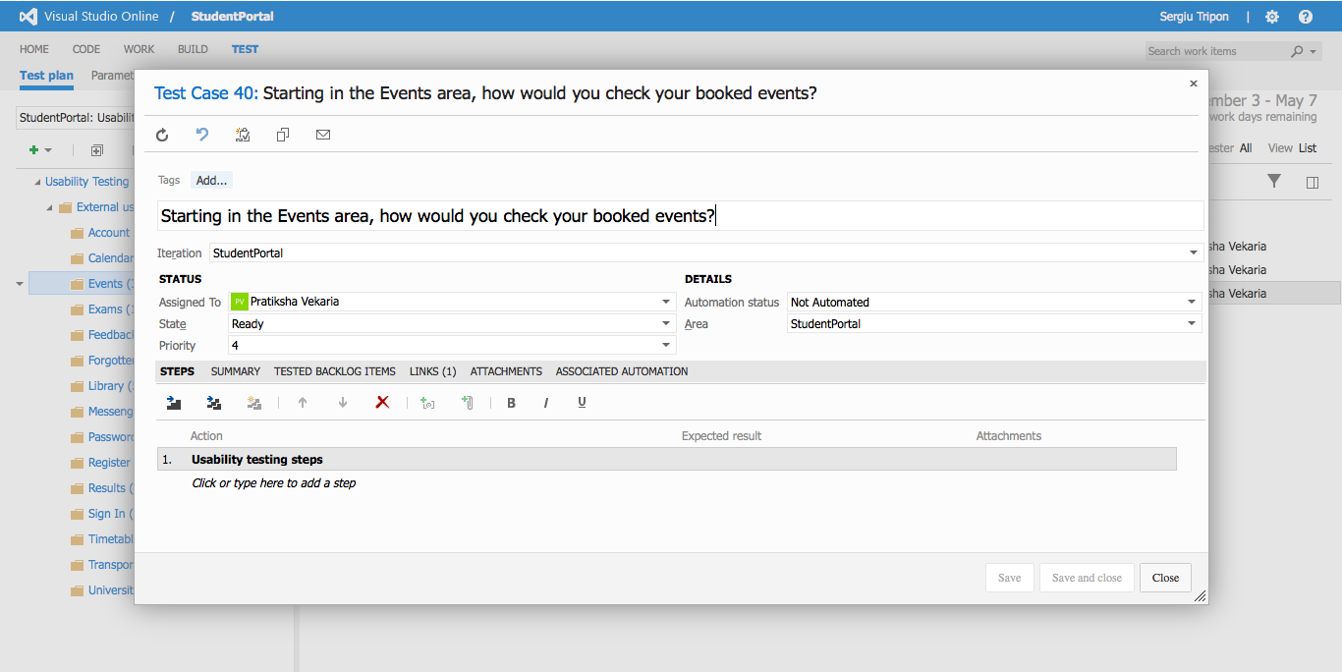

**Events** - detailed view of a test case

**Recording URL:** <https://student-portal.co.uk/usability-testing/?video=feedback>

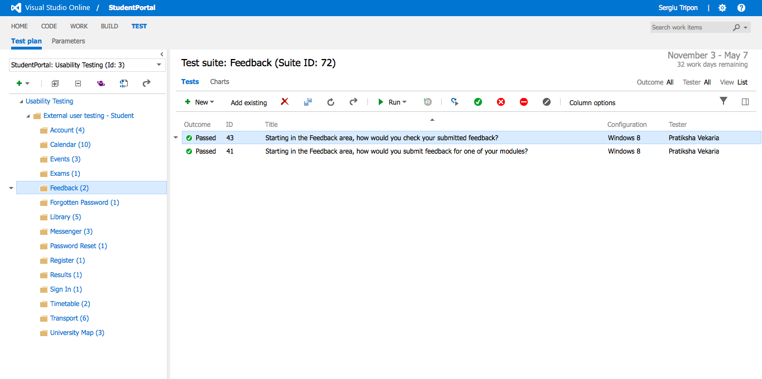

**Feedback** - overview of the test case(s)

**Recording URL:** <https://student-portal.co.uk/usability-testing/?video=feedback>

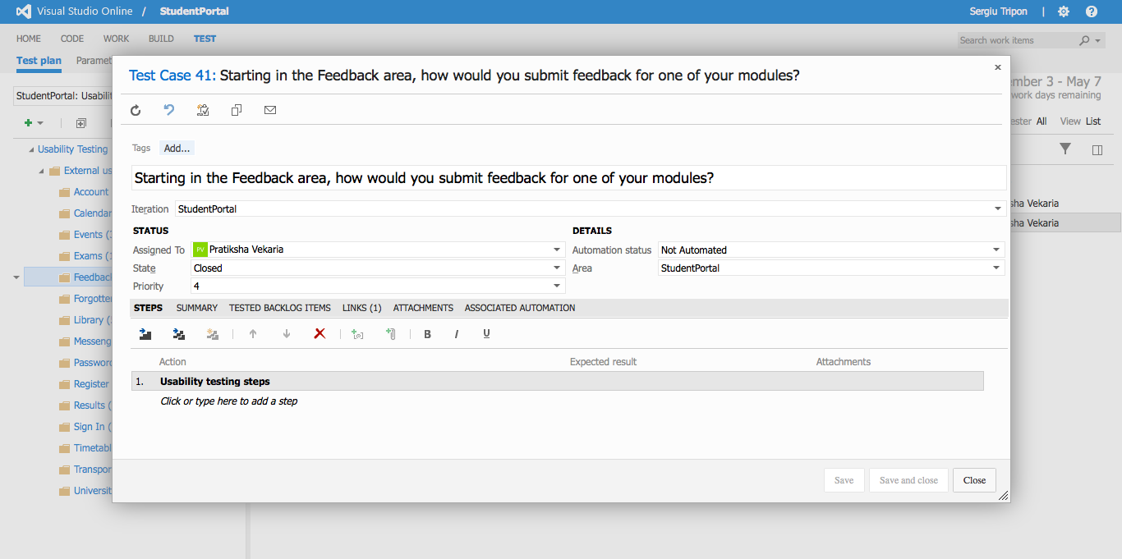

**Feedback** - detailed view of a test case

**Recording URL:** <https://student-portal.co.uk/usability-testing/?video=feedback>

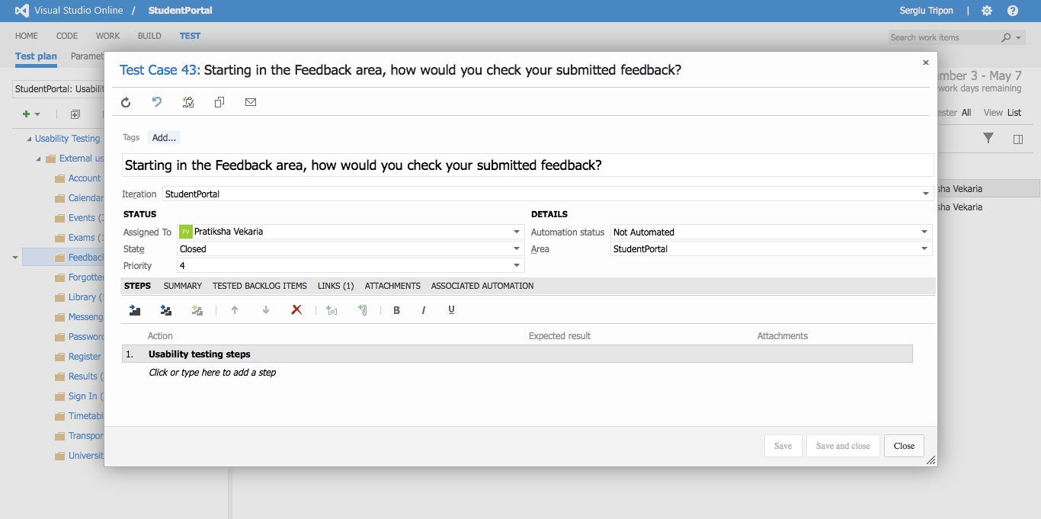

**Feedback** - detailed view of a test case

**Recording URL:** <https://student-portal.co.uk/usability-testing/?video=messenger>

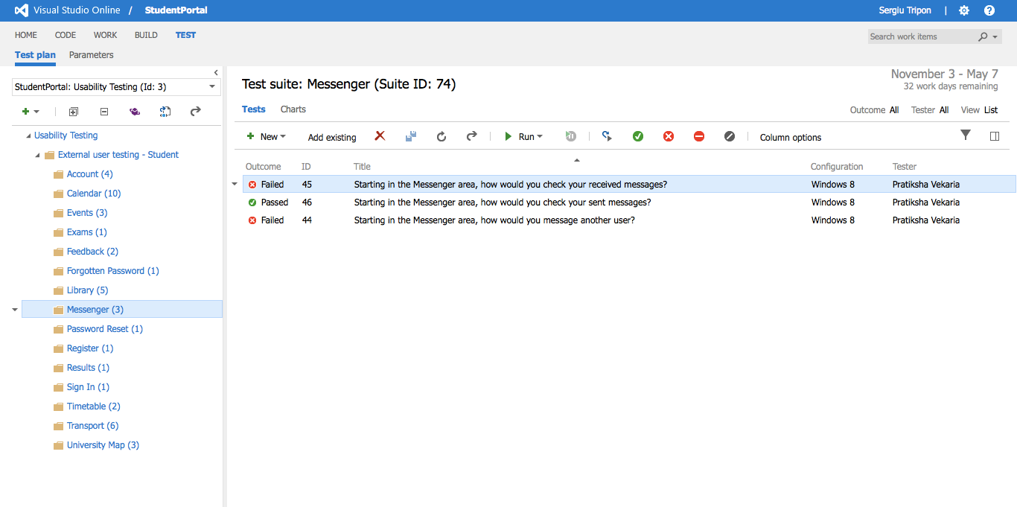

**Messenger** - overview of the test case(s)

**Recording URL:** <https://student-portal.co.uk/usability-testing/?video=messenger>

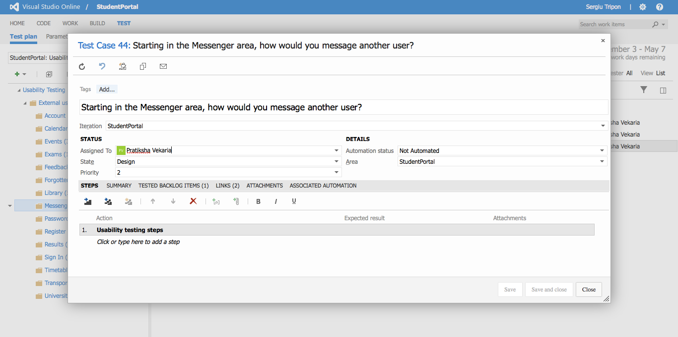

**Messenger** - detailed view of a test case

**Recording URL:** <https://student-portal.co.uk/usability-testing/?video=messenger>

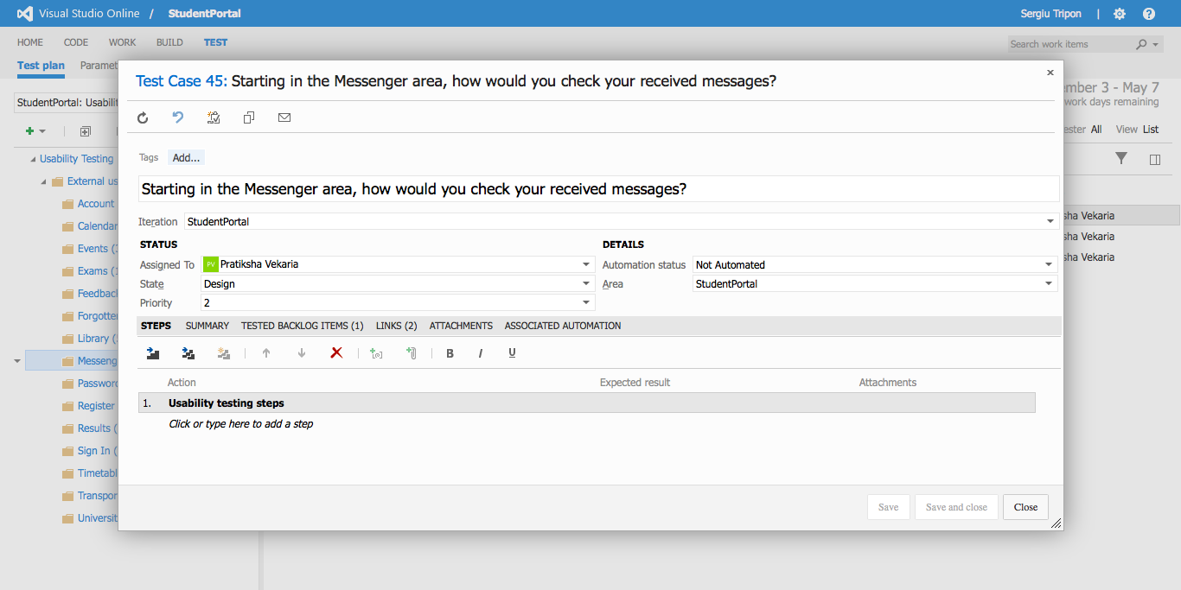

**Messenger** - detailed view of a test case

**Recording URL:** <https://student-portal.co.uk/usability-testing/?video=messenger>

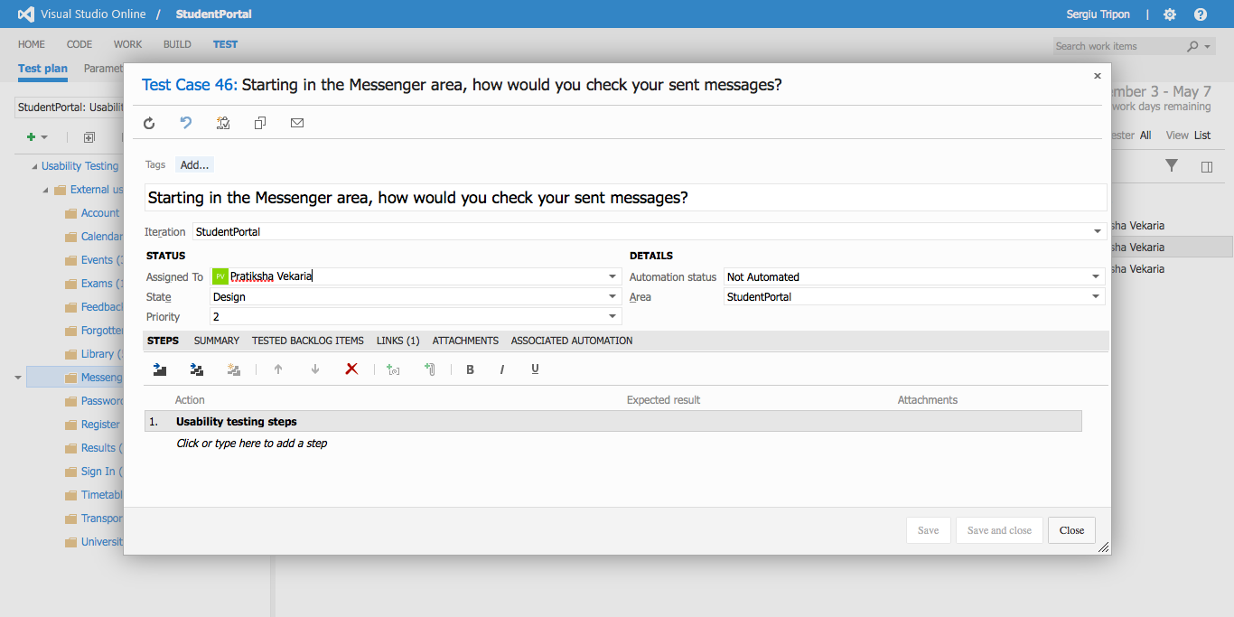

**Messenger** - detailed view of a test case

**Recording URL:** <https://student-portal.co.uk/usability-testing/?video=account>



**Account** - overview of the test case(s)

**Recording URL:** <https://student-portal.co.uk/usability-testing/?video=account>

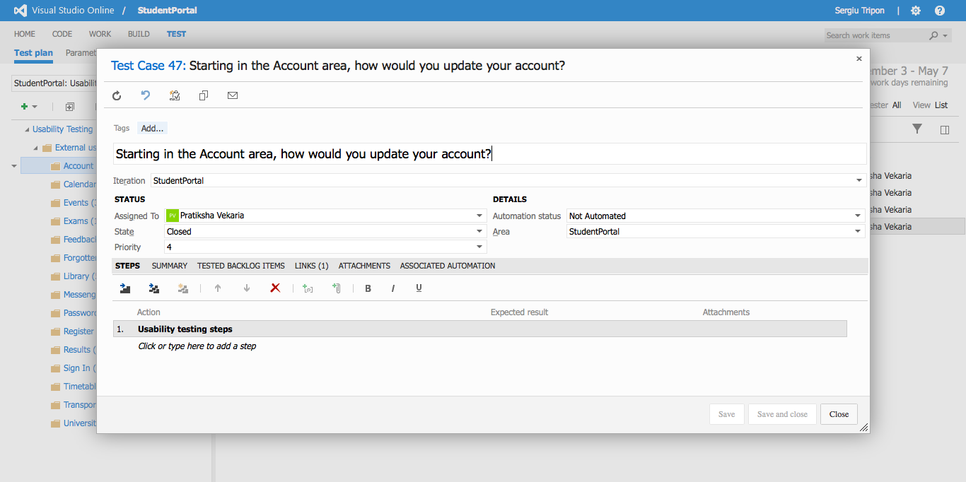

**Account** - detailed view of a test case

**Recording URL:** <https://student-portal.co.uk/usability-testing/?video=account>

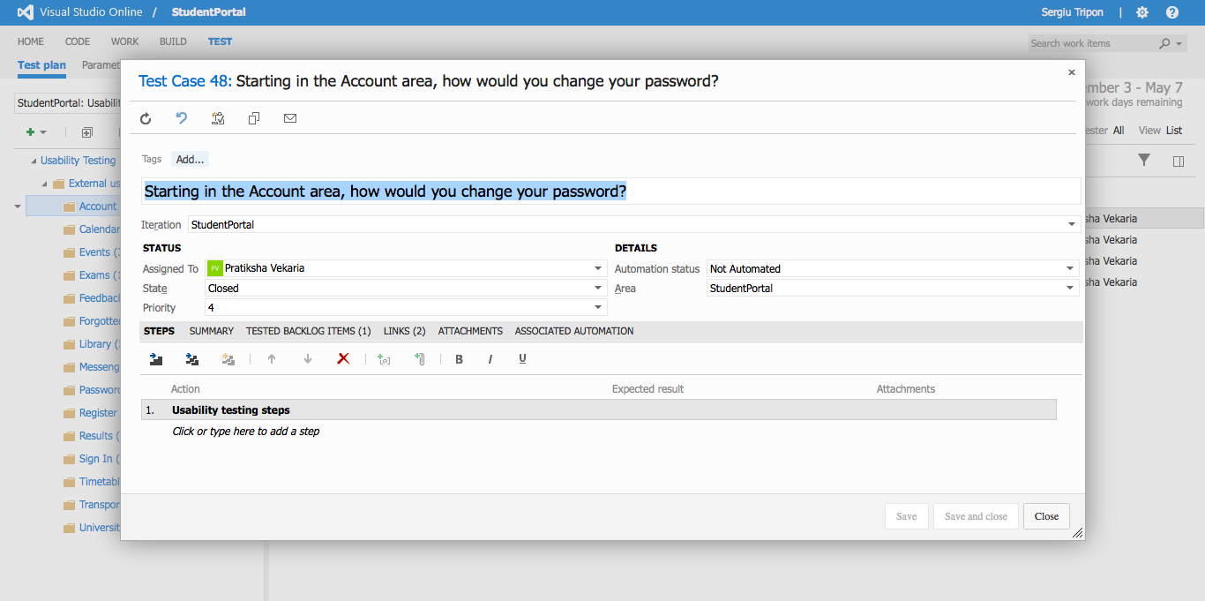

**Account** - detailed view of a test case

**Recording URL:** <https://student-portal.co.uk/usability-testing/?video=account>

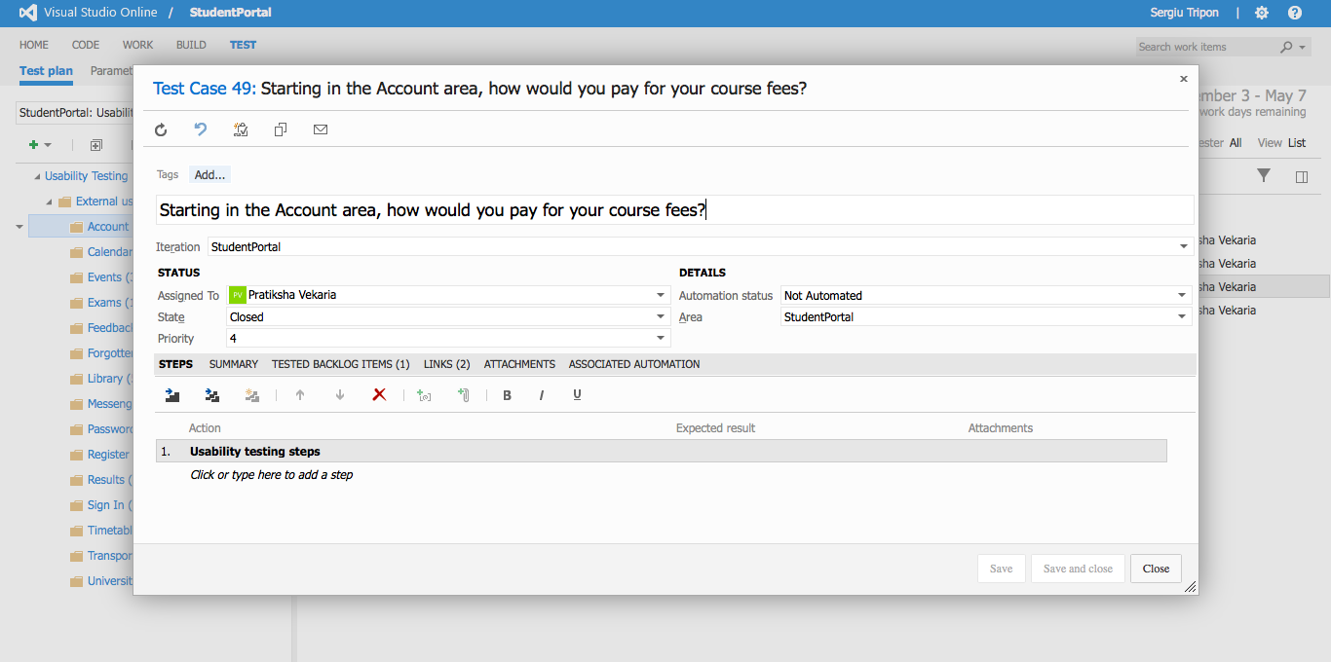

**Account** - detailed view of a test case

**Recording URL:** <https://student-portal.co.uk/usability-testing/?video=account>

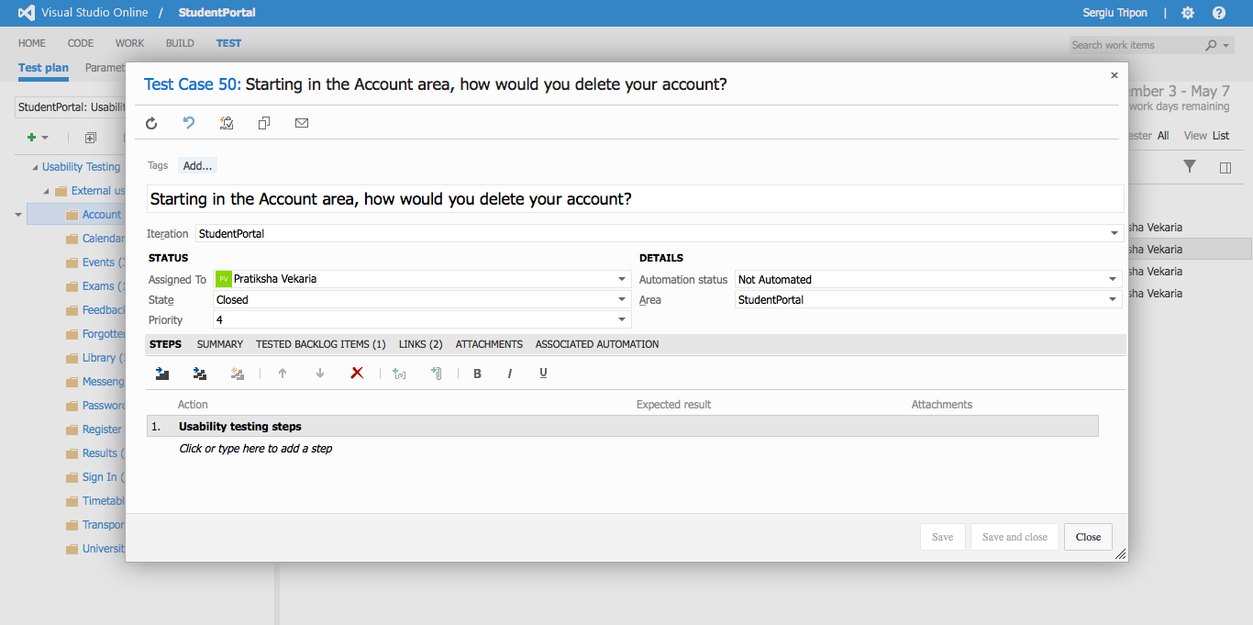

**Account** - detailed view of a test case

# Test results

**Recording URL:** <https://student-portal.co.uk/usability-testing/?video=account>

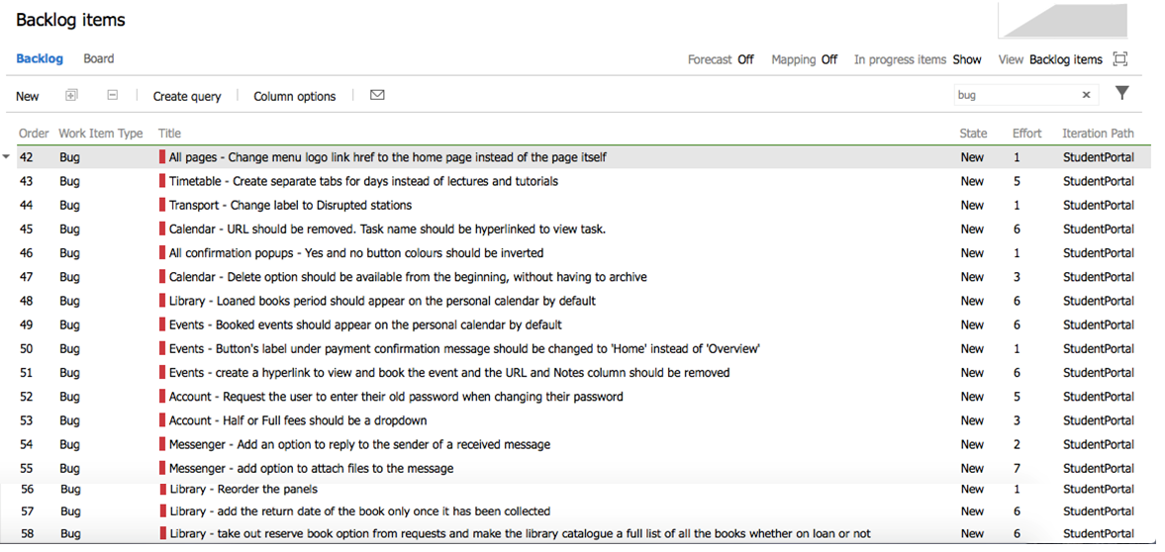

**Test results** - Overview

**Recording URL:** <https://student-portal.co.uk/usability-testing/?video=full-video>

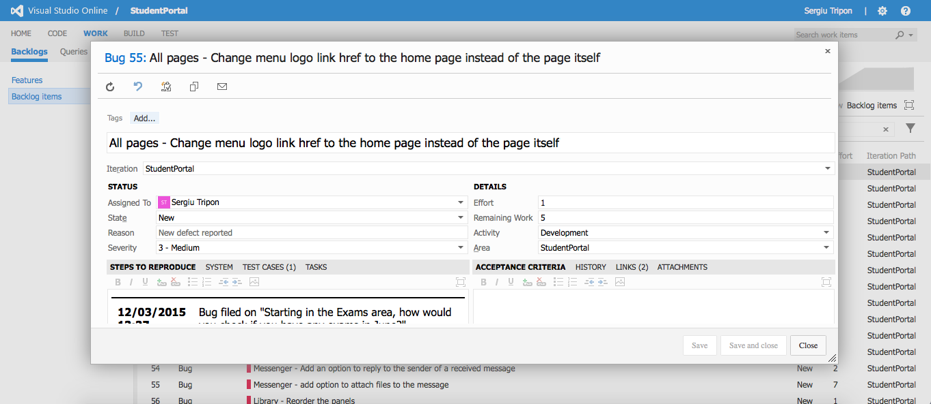

**All pages** - detailed view of a bug record

**Recording URL:** <https://student-portal.co.uk/usability-testing/?video=full-video>

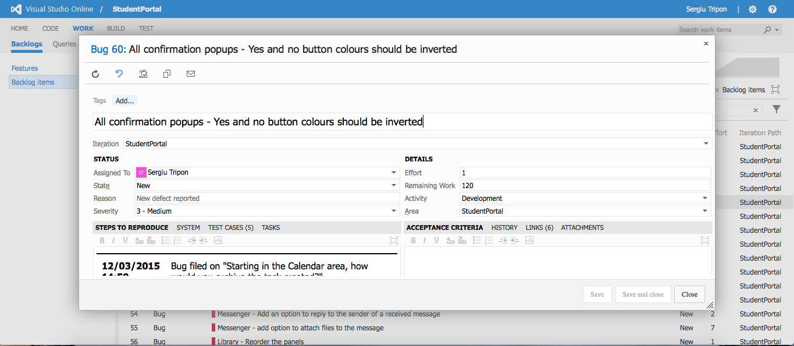

**All confirmation pop-ups** - detailed view of a bug record

**Recording URL:** <https://student-portal.co.uk/usability-testing/?video=timetable>

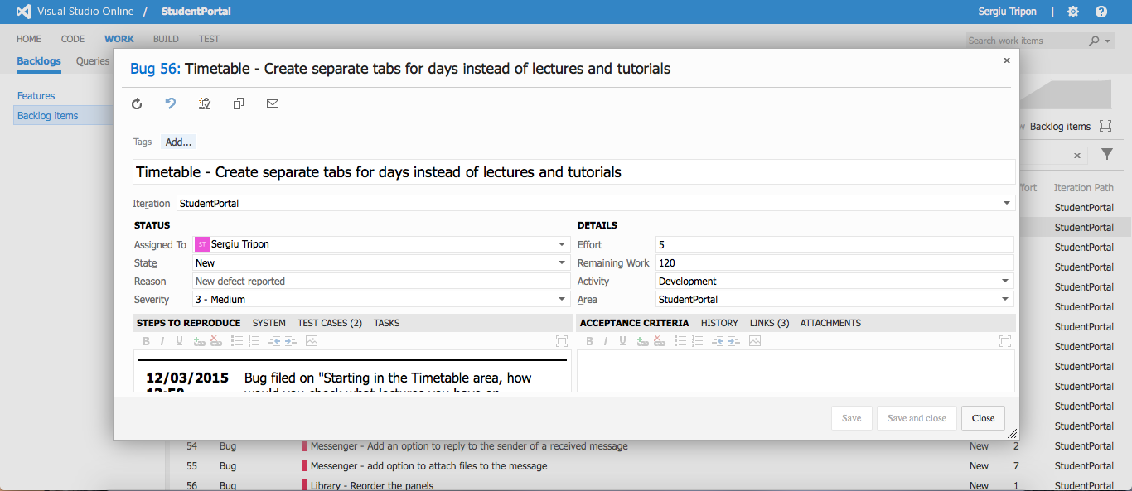

**Timetable** - detailed view of a bug record

**Recording URL:** <https://student-portal.co.uk/usability-testing/?video=transport>

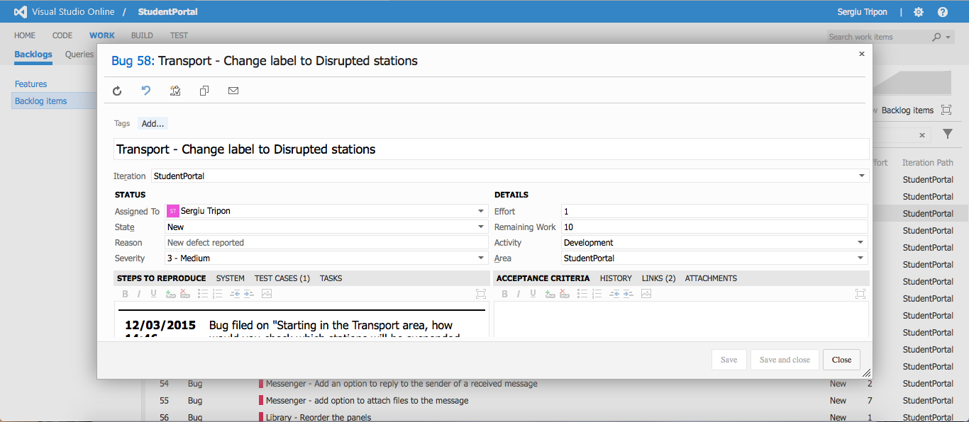

**Transport** - detailed view of a bug record

**Recording URL:** <https://student-portal.co.uk/usability-testing/?video=library>

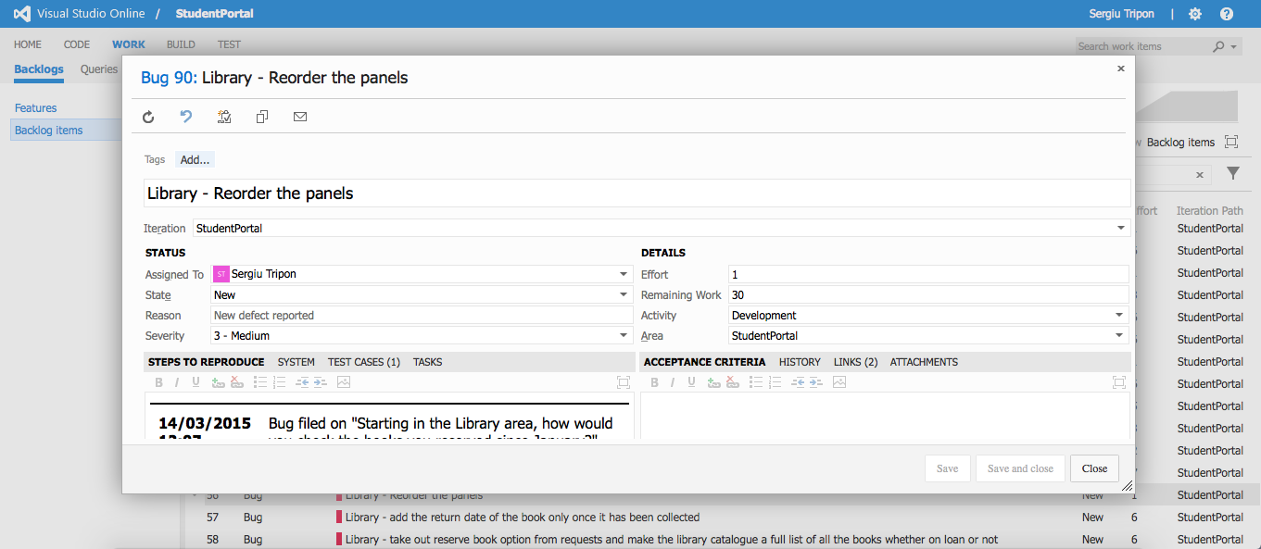

**Library** - detailed view of a bug record

**Recording URL:** <https://student-portal.co.uk/usability-testing/?video=library>

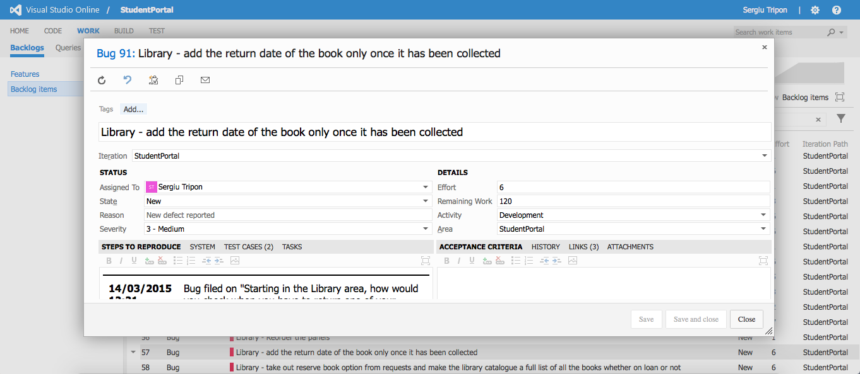

**Library** - detailed view of a bug record

**Recording URL:** <https://student-portal.co.uk/usability-testing/?video=library>



**Library** - detailed view of a bug record

**Recording URL:** <https://student-portal.co.uk/usability-testing/?video=library>

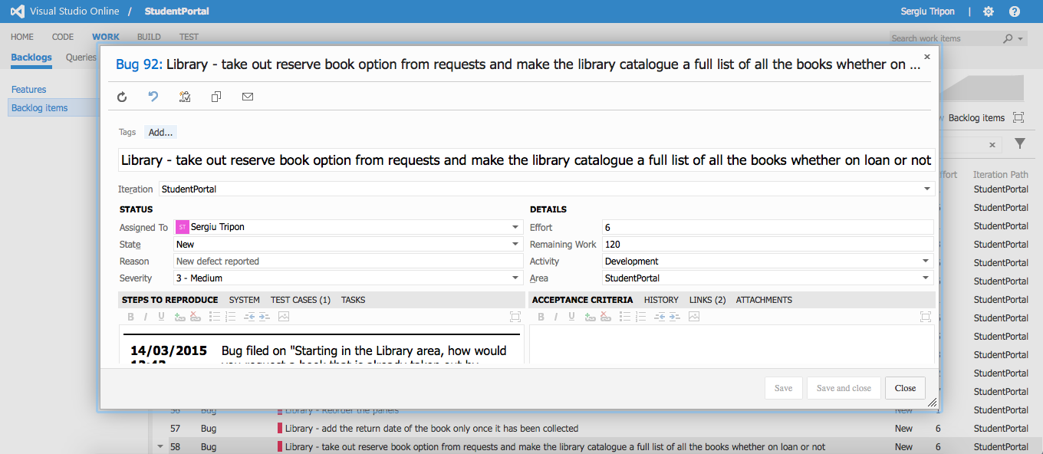

**Library** - detailed view of a bug record

**Recording URL:** <https://student-portal.co.uk/usability-testing/?video=library>

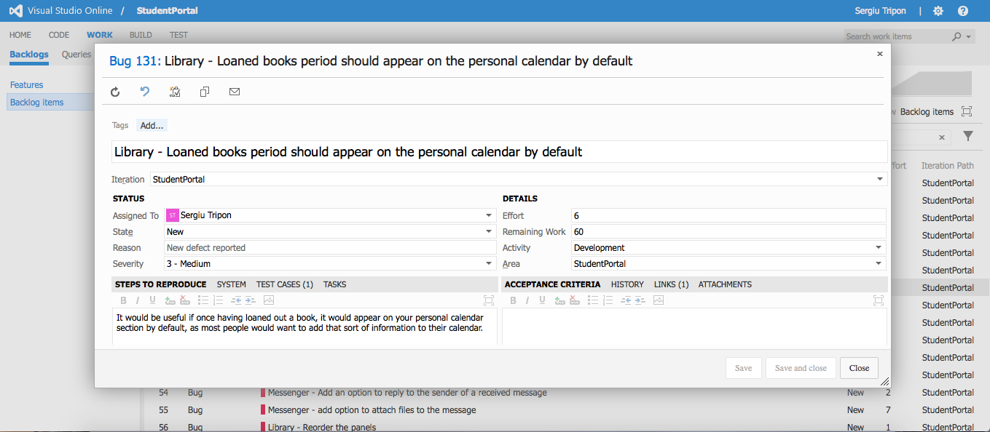

**Library** - detailed view of a bug record

**Recording URL:** <https://student-portal.co.uk/usability-testing/?video=calendar>

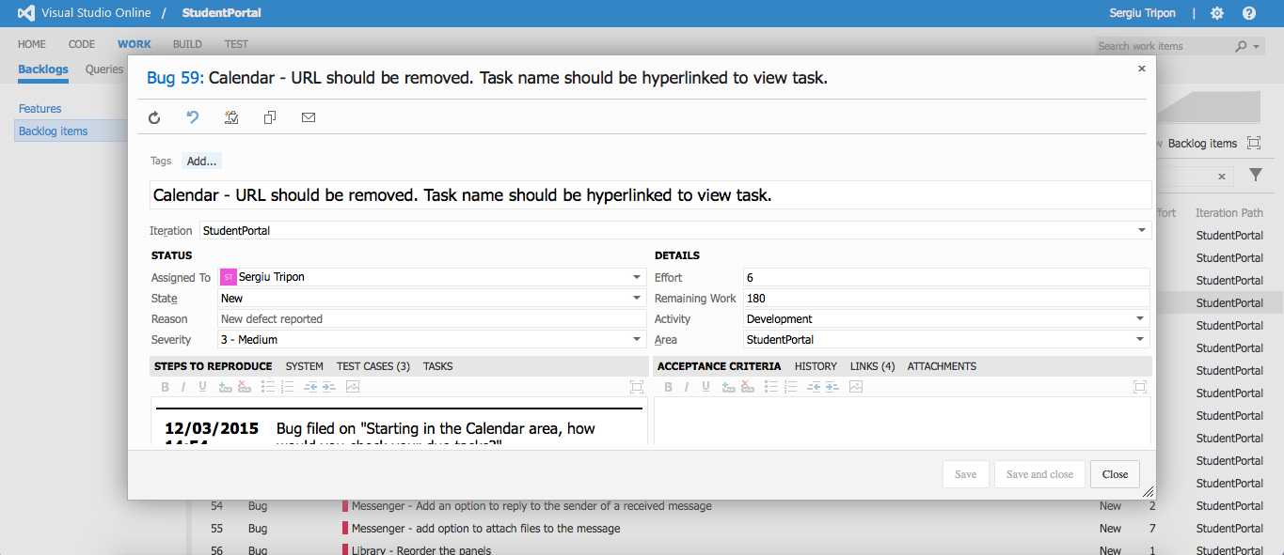

**Calendar** - detailed view of a bug record

**Recording URL:** <https://student-portal.co.uk/usability-testing/?video=calendar>

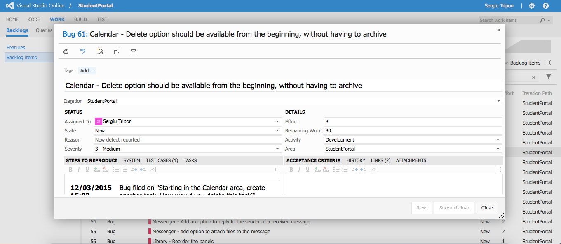

**Calendar** - detailed view of a bug record

**Recording URL:** <https://student-portal.co.uk/usability-testing/?video=events>

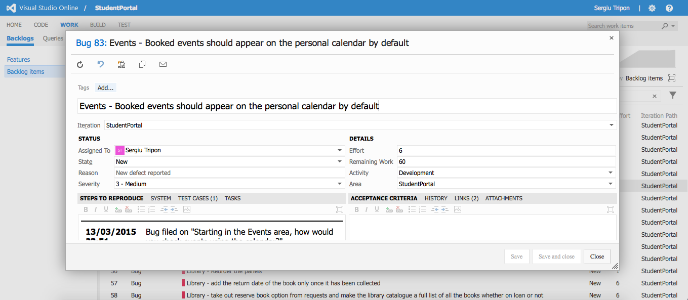

**Events** - detailed view of a bug record

**Recording URL:** <https://student-portal.co.uk/usability-testing/?video=events>



**Events** - detailed view of a bug record

**Recording URL:** <https://student-portal.co.uk/usability-testing/?video=events>

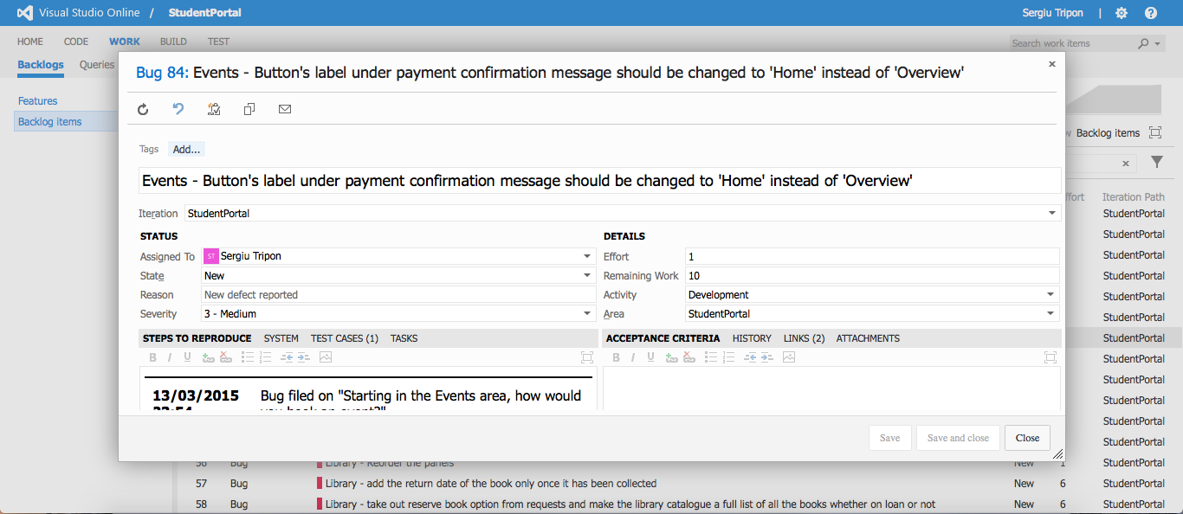

**Events** - detailed view of a bug record

**Recording URL:** <https://student-portal.co.uk/usability-testing/?video=events>

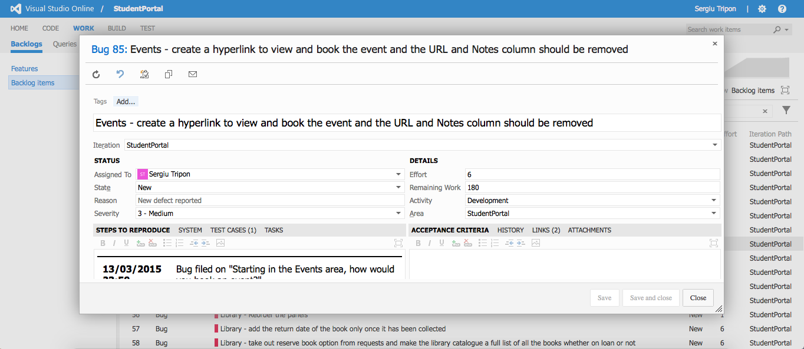

**Events** - detailed view of a bug record

**Recording URL:** <https://student-portal.co.uk/usability-testing/?video=messenger>

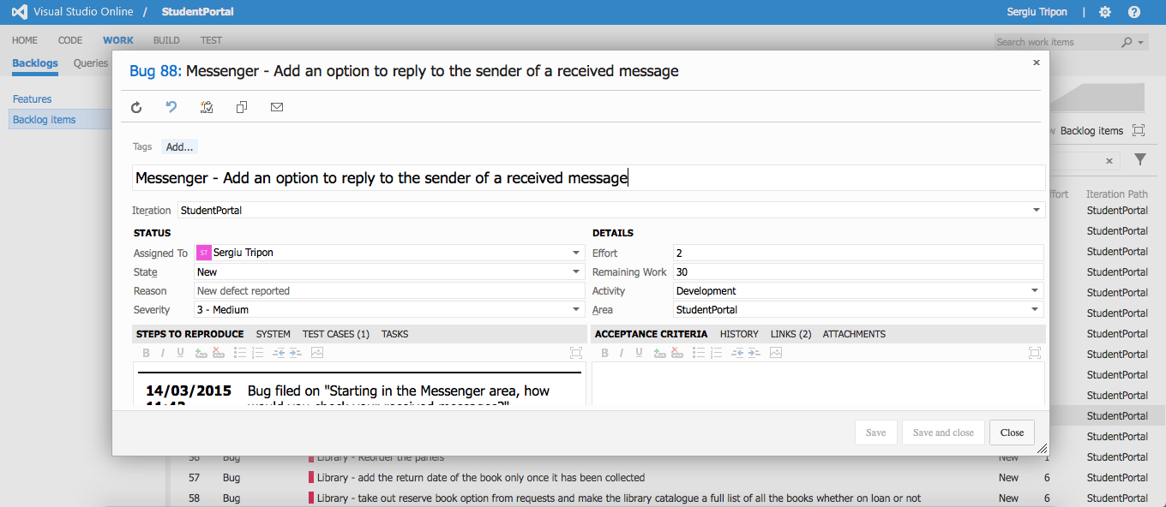

**Messenger** - detailed view of a bug record

**Recording URL:** <https://student-portal.co.uk/usability-testing/?video=messenger>

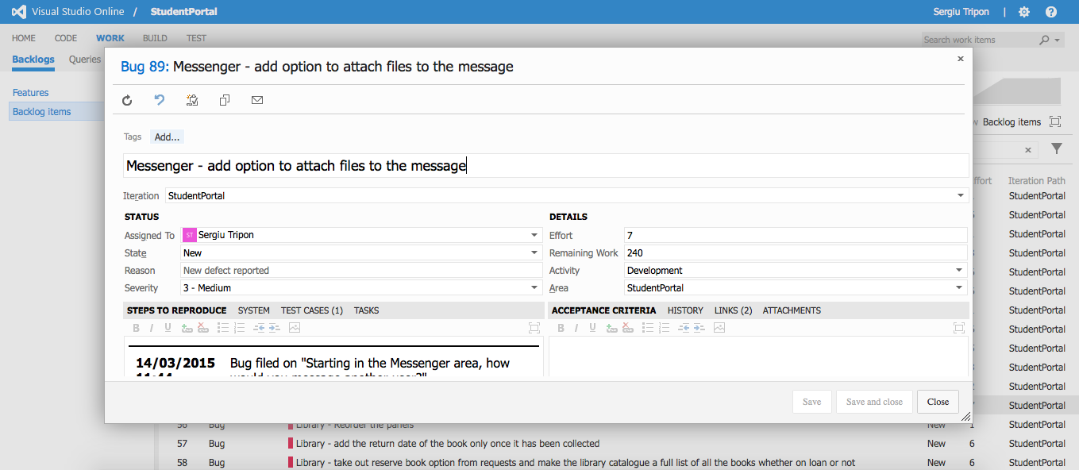

**Messenger** - detailed view of a bug record

**Recording URL:** <https://student-portal.co.uk/usability-testing/?video=account>

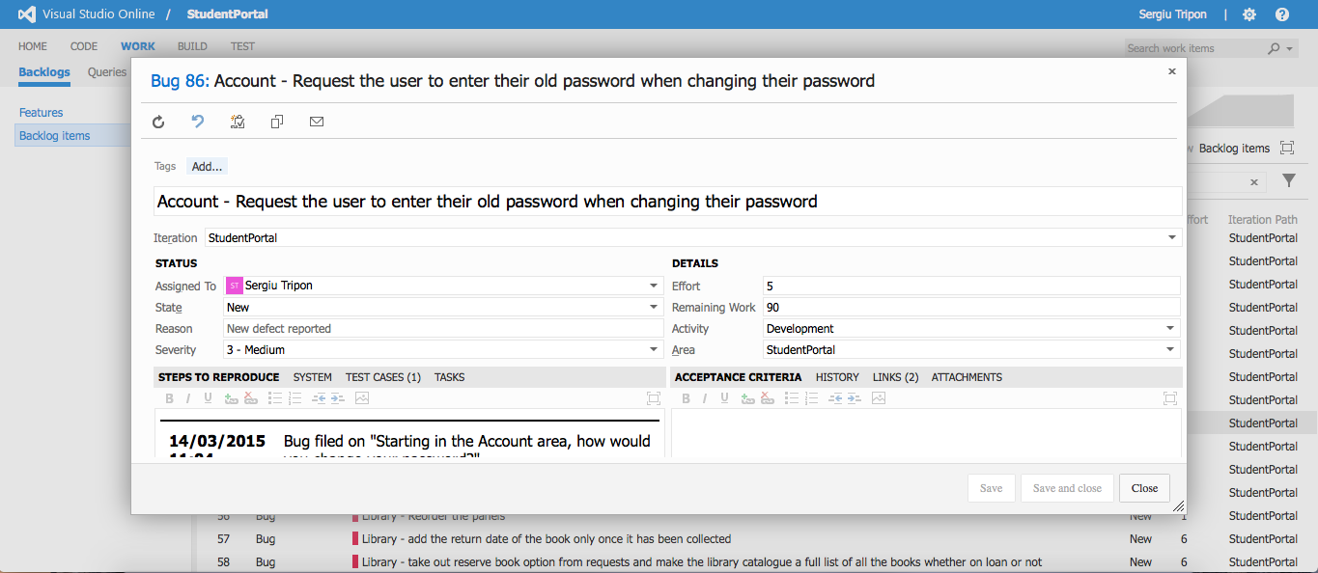

**Account** - detailed view of a bug record

**Recording URL:** <https://student-portal.co.uk/usability-testing/?video=account>

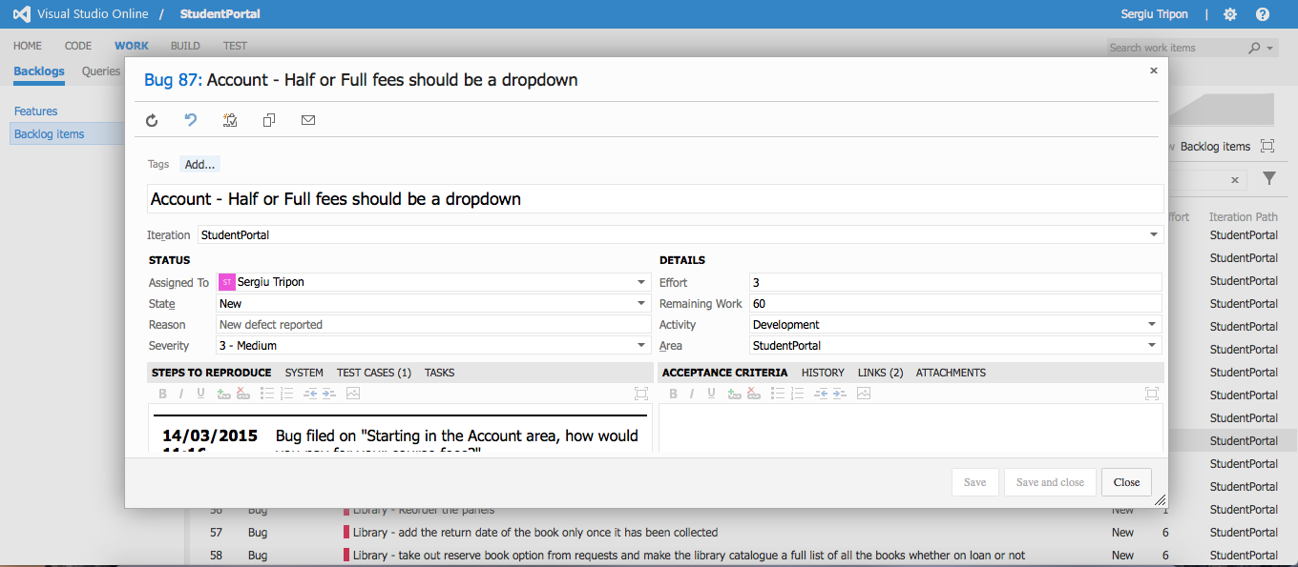

**Account** - detailed view of a bug record

# Github

All the bugs recorded in Visual Studio Online were then also created within Github (see Figure 1 and 2), the tool used to host and version control the application code. Github provides features which are harder to achieve in VSO. One of those features are assigning tags which are either provided by Github or custom created. In VSO, the developer would need to create separate “Feature” records. The use of tags enabled the developer to differentiate between different types of issues or testing. The majority of the bugs recorded during the usability testing phase turned out to not be actual bugs, but enhancements to the system.

Bugs are aspects of the system that should have worked or been available but weren’t. Enhancements are comments on aspects of the system which would add to the current usability or improve it.

The developer used two tags, the “Bug” and “Enhancement” tags to differentiate between the issues that were actual bugs and the ones that were more enhancements to the application than bugs. Also, a usability tag was created which was assigned to all the bugs (See figure 3). This will help the developer differentiate between the usability and unit testing.

Another feature that Github offers is the ability to create a milestone which the developer can add bugs to. The milestone has a due date, so it allows the user to have a structure schedule of fixing bugs or implementing new features. The developer created a milestone for the usability testing bugs and enhancements that were recorded. (See figure 4 and 5)

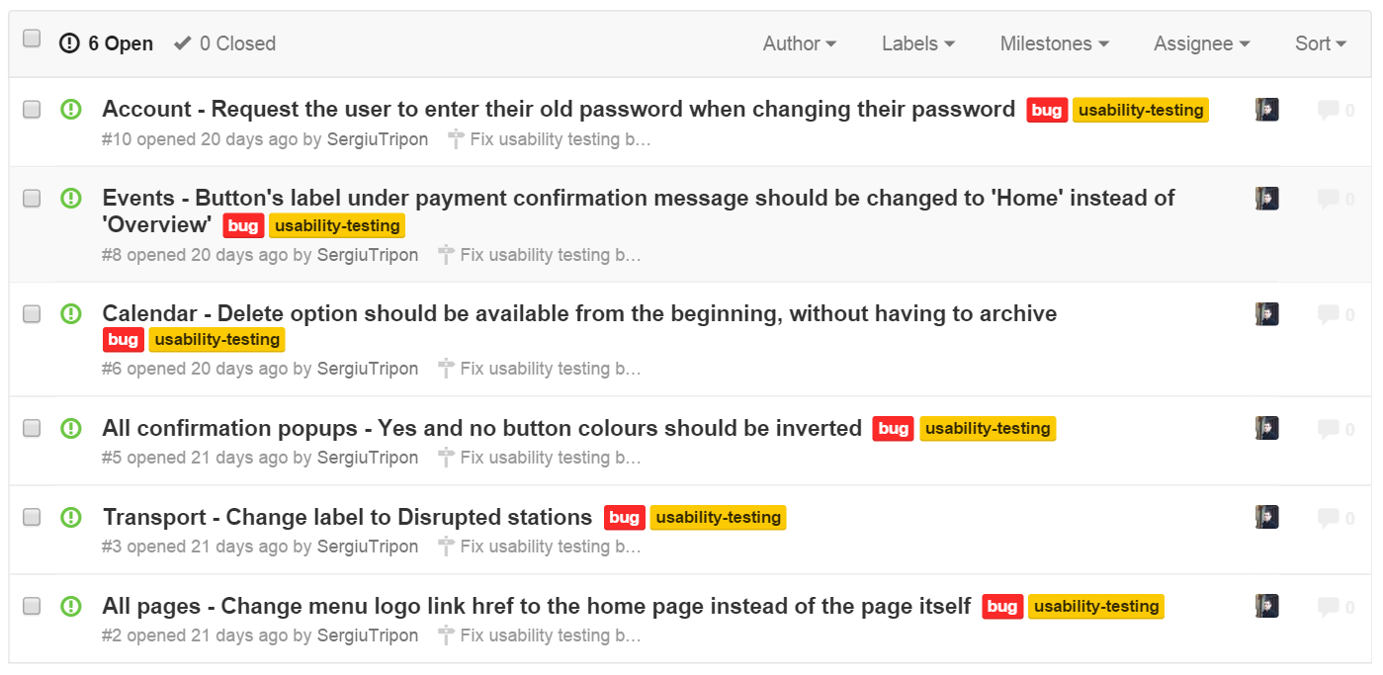

**Figure 1. Bugs created on Github**

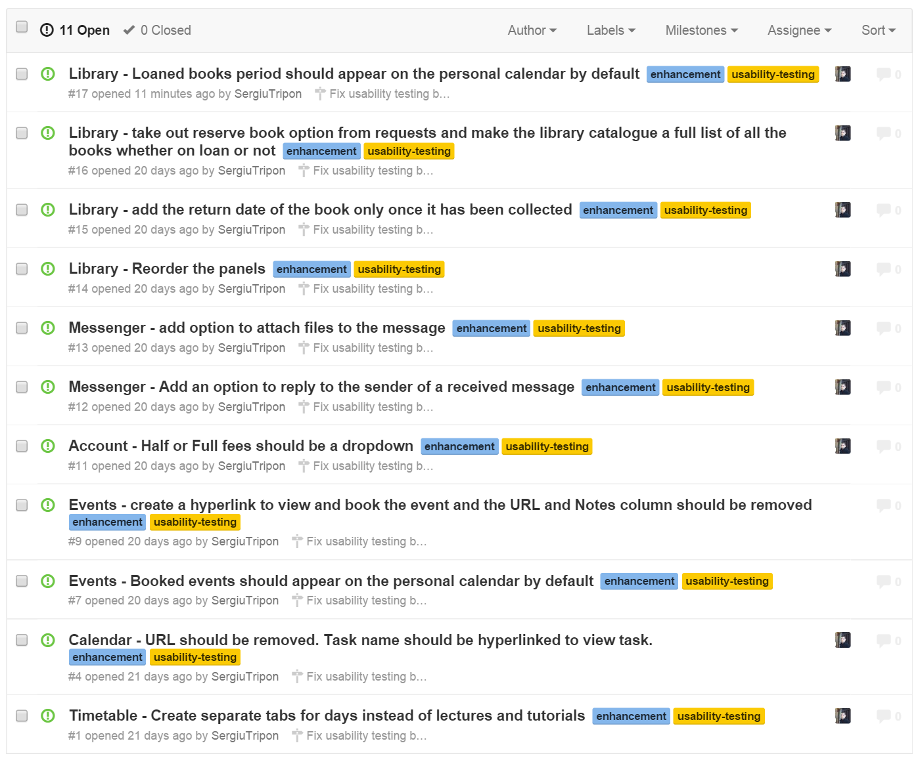

**Figure 2. Enhancements created on Github**

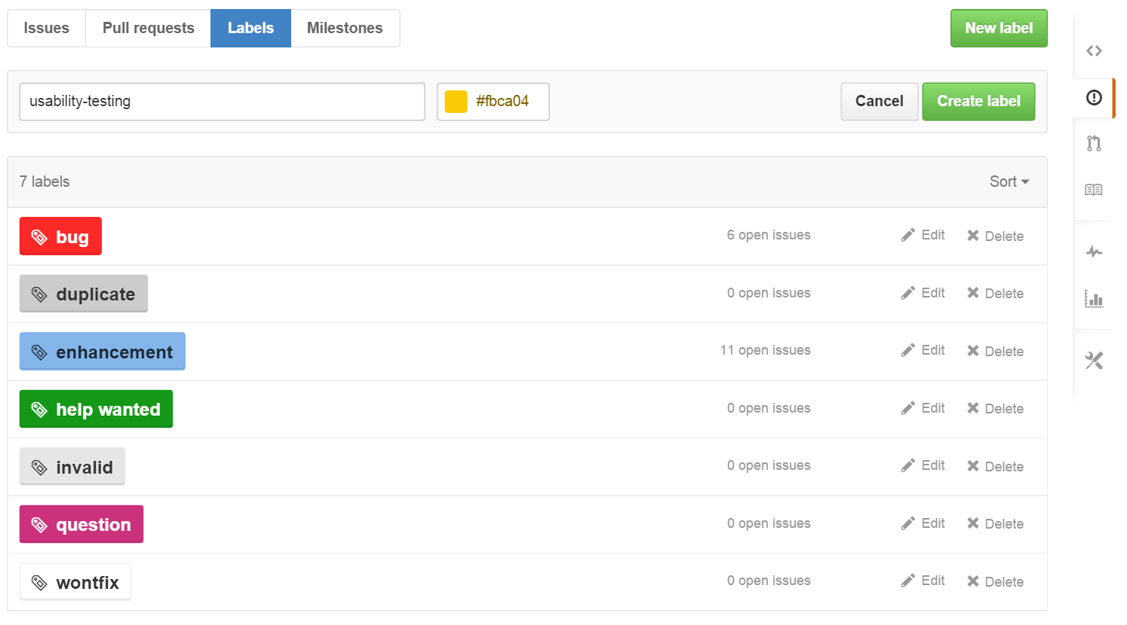

**Figure 3. Creating a custom label on Github**

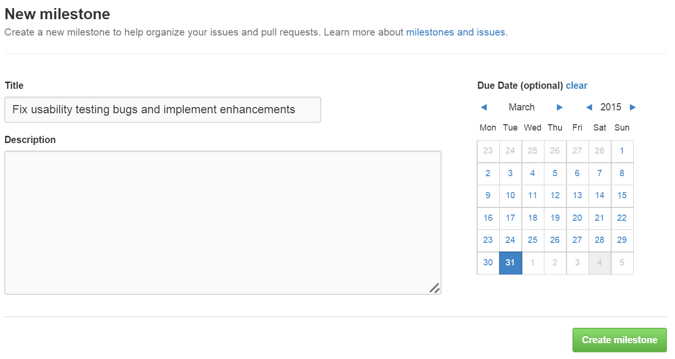

**Figure 4. Creating a milestone to fix usability testing bugs and implement enhancements on Github**

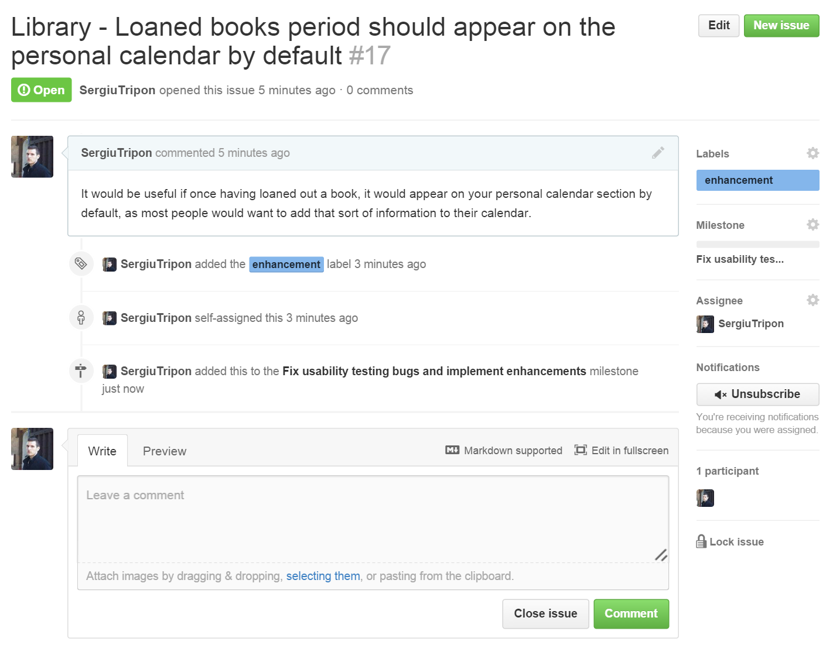

**Figure 5. Adding an enhancement to the milestone created (Figure 4) on Github**

After the bug fixing and enhancement implementation phase was completed, the developer went back to both VSO and Github and change the status of the specific bugs and enhancements that have been fixed or implemented. Overall, there were 15 out 16 bugs or enhancements that were fixed or implemented. Only one enhancement, “Messenger – add option to attach files to the message”, was not implemented as it was considered too complex to implement at this stage in the project, but it may be implemented at a later stage. (See figures 6, 7, 8 and 9)

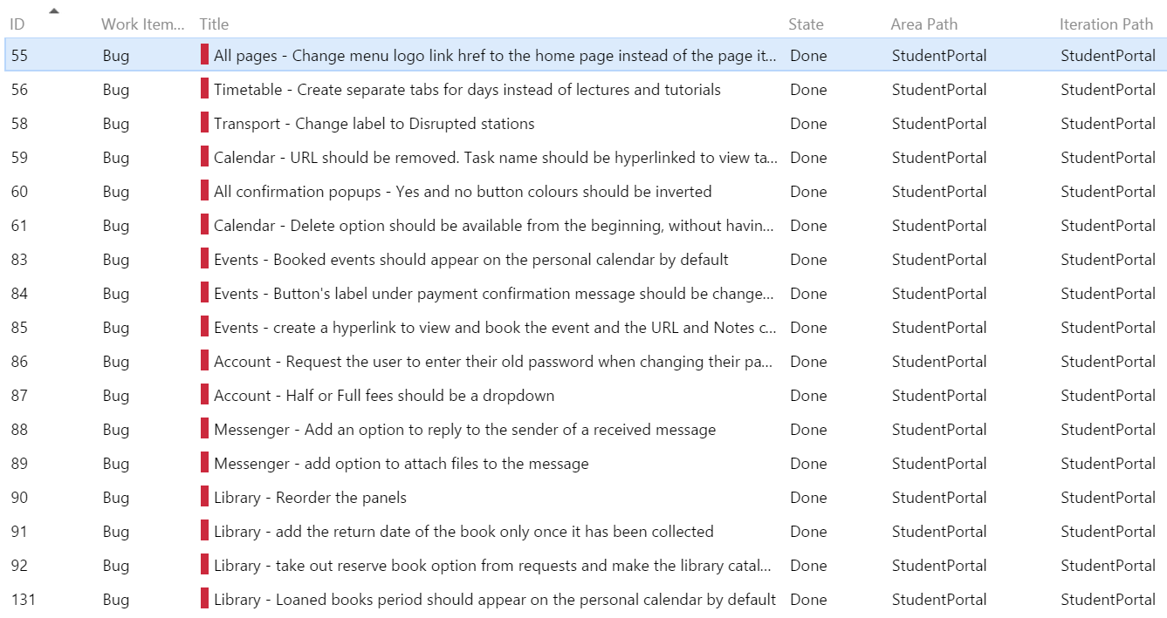

**Figure 6. The 15 bugs that were fixed were changed to State: Done on Visual Studio Online**

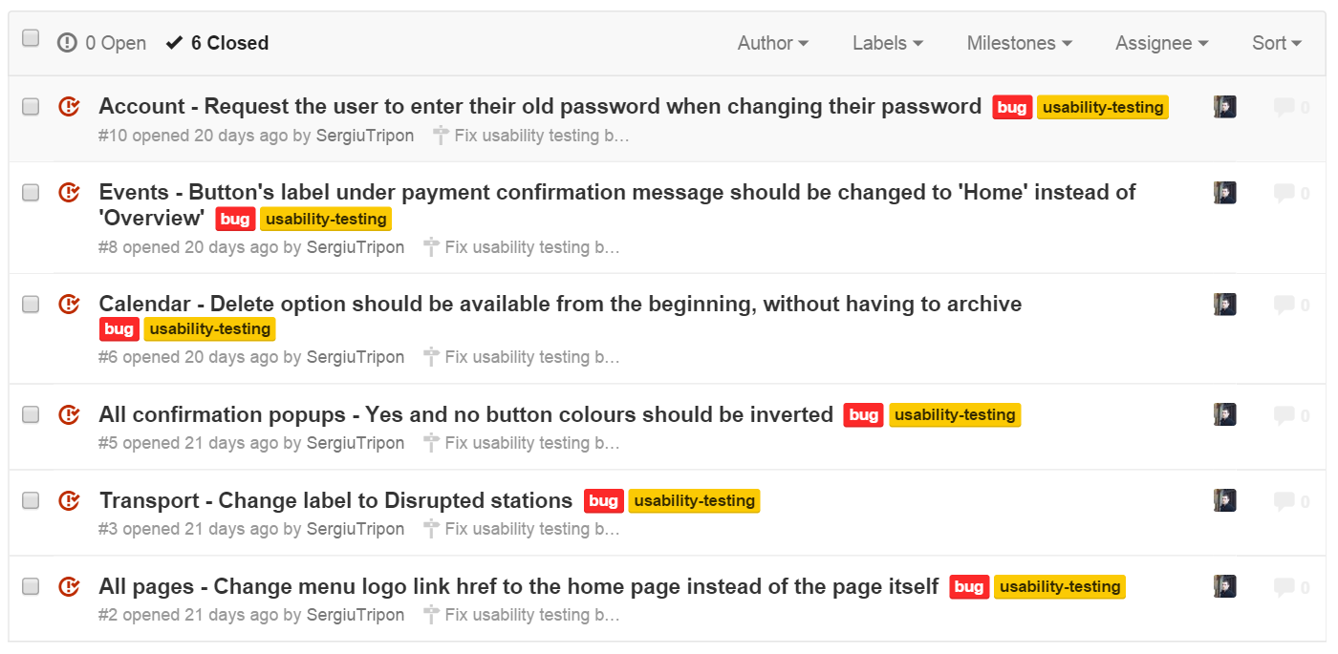

**Figure 7. 6 bugs were fixed and their state was changed to Closed on Github**

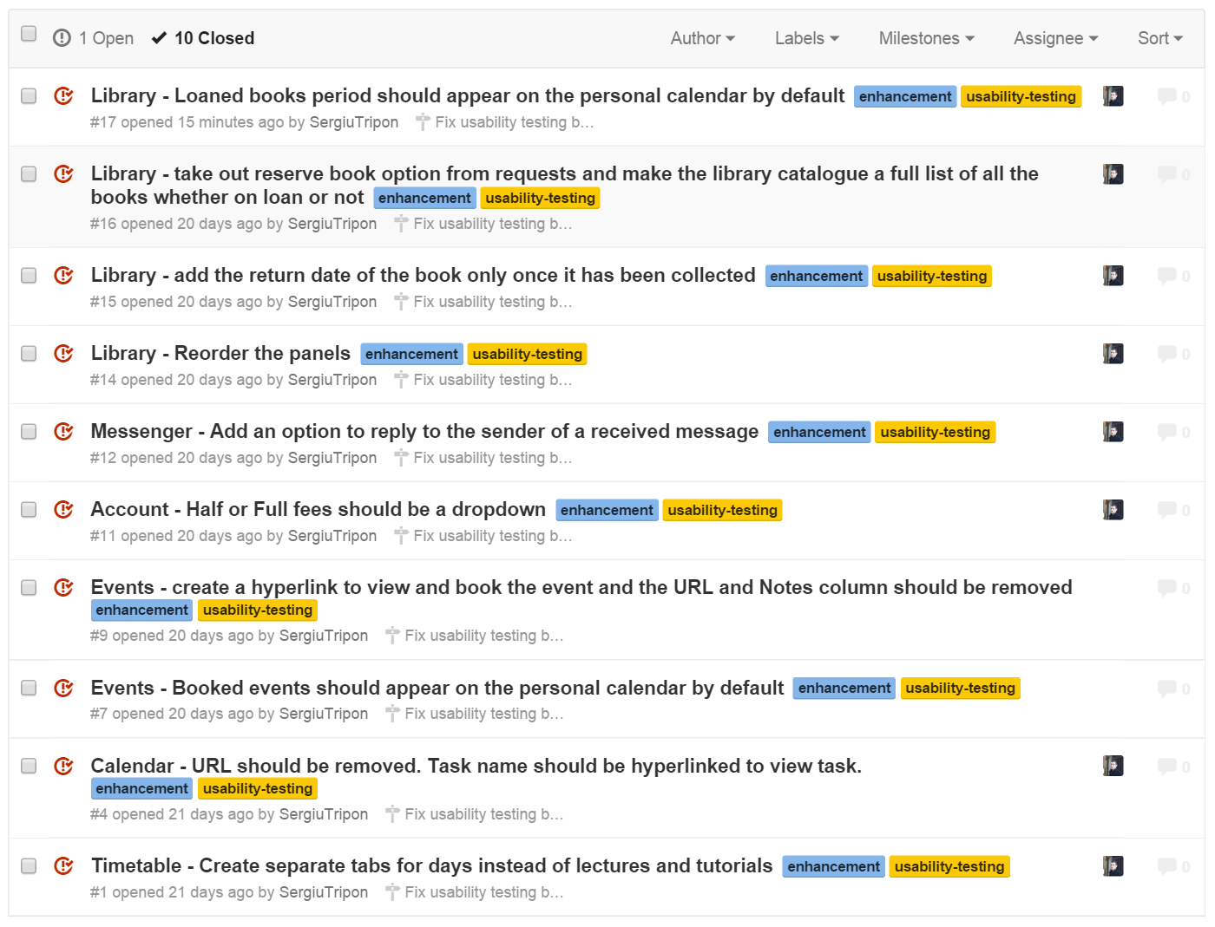

**Figure 8. 10 enhancements were implemented and their state was changed to Closed on Github**

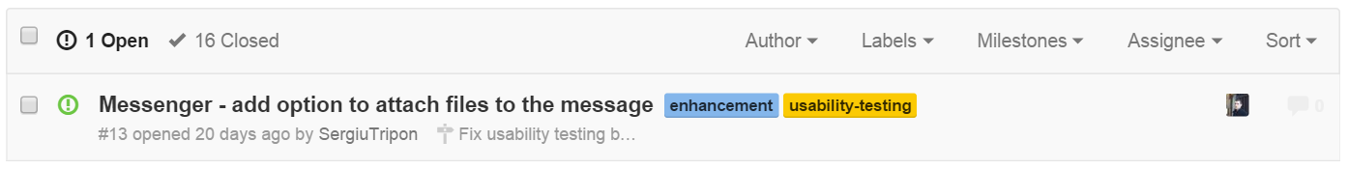

**Figure 9. The only enhancement that is left to be implemented and it may be, at a later stage**

# Conclusion

To conclude, the developer believes that the usability testing phase helped by showcasing the difference between how the end users and the developers looks at software applications. It also helped with understanding how important the usability aspect of an application is, as it represents the reputation of the application and influences the first opinion of the end user. Overall, the developer thinks that the usability testing phase was extremely beneficial in making the application more logic and coherent. In addition to that, the developer also gained a lot of experience and learnt a lot about the end user interaction with an application which will definitely help when building applications in the future.